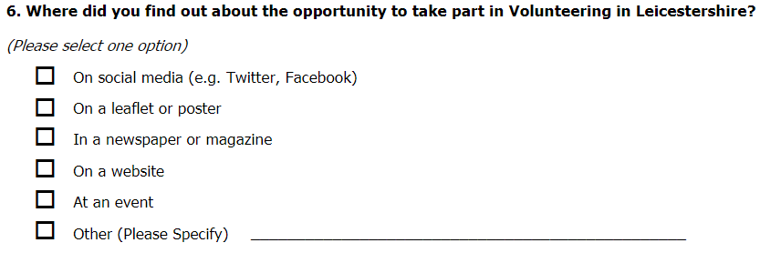

**6) Where did you find out about Deaf Get Active?** Please tick**🗸one**

🞏 Social Media - for example Facebook , Twitter

🞏 Leaflet or poster

🞏 Newspaper or Magazine

🞏 Website

🞏 At an event

Other – please tell us

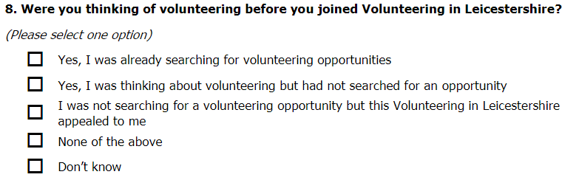

|  |  |
| --- | --- |
|  | **8) Before Deaf Get Active, were you thinking about volunteering?**   Please tick🗸one   * Yes, I was looking for volunteering * Yes I was thinking about it * I was not thinking about volunteering. But Deaf Get Active was interesting for me. * None of the above * I don’t know |

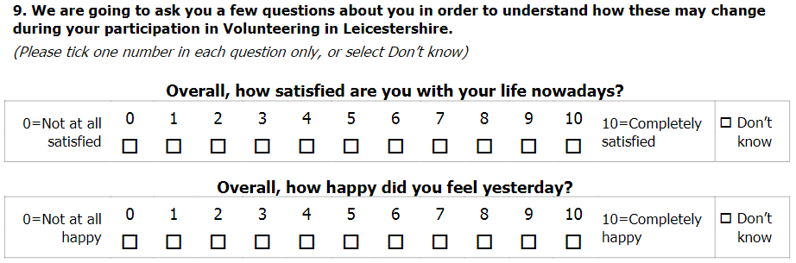

|  |  |  |
| --- | --- | --- |
| **It’s all about you** | **9) The next questions are about you and your life.**  We want to see if things change while you are a volunteer with Deaf Get Active. We will ask you these questions again every six months | |
|  | **How satisfied are you with your life?** Please circle the number. Choose from  0 to 10. | 10=  Completely  satisfied             0 = Not at  all satisfied  Don’t know 🞏 |
|  | **How happy did you feel yesterday?** Please circle the number.  Choose from  0 to 10 | 10=  Completely  happy  0 = Not at  all happy  Don’t know 🞏 |

Ladder diagram – credit, with thanks: [New Philanthropy Capital](https://www.thinknpc.org/resource-hub/measuring-the-well-being-of-young-people-with-special-educational-needs/)