Blacksbridge Athletics Track, Gloucester

What this case study is about?
This is the story of how Blacksbridge Athletics Track, the only proper athletics facility for Gloucester & surrounding areas, was saved from a slow death through the efforts of a group of dedicated volunteers and a forward-thinking Local Authority. This is an example of where a solution was found to complex land ownership issues and where a brand new organisation was established to take over management of the facility. The story demonstrates how dedicated management by passionate people can lever in investment, grow usage and create a new offer for ‘all ability’ sportspeople with wheelchair racing and other Paralympic disciplines.
What was the problem?

Blacksbridge Athletics Track, built and owned by Gloucester City Council, and used by two different athletics clubs as well as schools and individuals, was unfortunately in a poor state of management and disrepair. Floods in 2007 had worsened the situation, and parts of the facility were closed for health and safety reasons. There were large holes in the track and equipment was in a poor state of repair. Gloucester City Council made the decision to close the track and invest in new athletics facilities on a different site as part of a major sports complex. These plans fell through in 2011 however, when they could not raise enough partnership funding for the project.

Meanwhile, a coach at one of the athletics clubs using the track, decided to launch an appeal to raise money towards the planned new track. When the big plans were abandoned, there were donations of £35,000 already pledged or made, and a decision had to be made as to what to do with the money.
A meeting was arranged with a City Councillor with responsibility for sports and leisure, to discuss the future for athletics in the City. What came from that meeting was a plan for rescuing Blacksbridge Track.
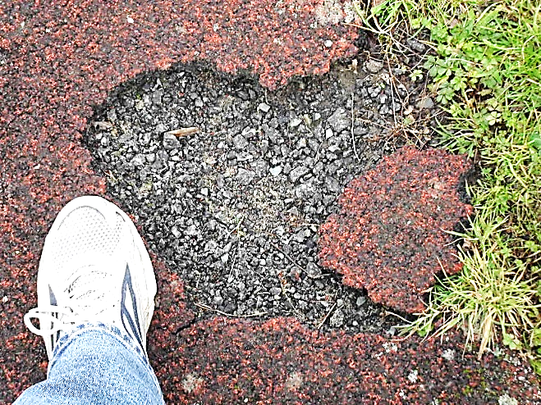
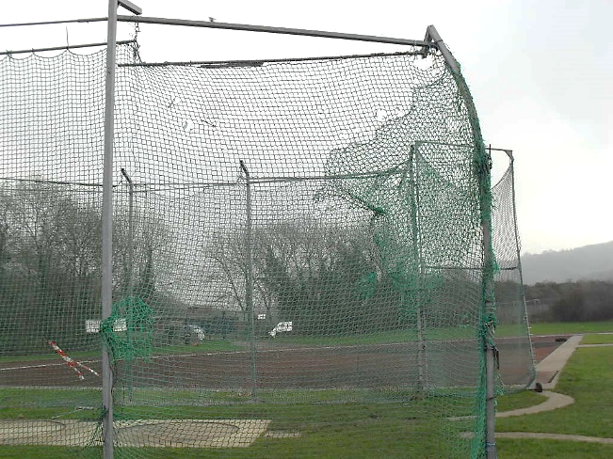

What was the solution?

The Council had funds available from flood insurance to reinvest in sports facilities. However, there was no money for the ongoing running or management of the track. However, if the athletics clubs could take on management of the site, the Council would be willing to make some much needed repairs before handing it over. The final piece of the funding jigsaw would be the Sport England Inspired Facilities fund. Club members began work on a business plan for running the facility, whilst GCC put in a funding application to Sport England, with the emphasis on making the site safe and secure with facilities fit for all levels of training from schools to elite sports-people. They were awarded £100,000 in late 2011. One of the terms of the funding was for GCC to have a lease in place for at least 7 years with the potential of asset transfer at some point in the future.

There were two more hurdles to overcome in the transfer plans. At the time, two athletics clubs were using the track facilities and the adjoining club house. It was not a fair solution for the track to be handed to just one of the clubs, nor did the Council favour a competitive solution. So the team involved in negotiations decided to establish a new charitable company to take on management of the track from the Council. Gloucester Athletics Track Management Ltd. (GATM) was incorporated in 2011 and registered as a charity in 2012. There were a mix of Trustees with about half coming from the athletics clubs.

The final hurdle was the land ownership situation. Blacksbridge Athletics Track was built and managed by Gloucester City Council but the land on which it sits is owned by the Trustees of Gloucester United Schools. The Trustees were not keen to alter the existing lease with the City Council or allow a sub-lease, but Sport England funding was dependent on some degree of transfer. The compromise solution was a 5 year management agreement for GATM along with a peppercorn license to occupy. Whilst this appears in legal terms to lack security, GATM are confident that the intention of the Council is for GATM to be the long term manager of the site for as long as they are able and that in the future they will be offered a long lease.

“I'm utterly confident that the five year 'backstop' represents merely an abundance of caution on behalf of the City Council”

An interesting element is the financial agreement between GATM and GCC. GATM are responsible for collecting all income and maintaining the facility. Any surplus generated must be used for ‘the accumulation of a sinking fund to meet the cost of any future renewal or replacement of the running track.’

What is the business model?
This is a lean and mean business model with the primary aim of keeping the athletics facilities accessible and affordable. It is totally based on volunteer staffing. Trustees and other volunteers are very hands on, taking on everything from bookings and collecting fees to carrying out minor repairs, stewarding events and purchasing equipment. The biggest costs are equipment replacement, utilities and insurance. £10,000 has been put into a sinking fund in the first 3 years of operation.

Yearly income averages around £20,000 and this is made up of club hire, fees for occasional use and hire for events. Clubs pay a booking fee for regular use and club members can also use the facilities on a pay as you go basis. Trusted users can access the site themselves at times when it is not open for clubs. There is a degree of trust in terms of payment for use on a “pay-as-you-go” basis.

In addition, GATM has raised over £60,000 in donations towards equipment such as race wheelchairs, hurdles etc. They have received a lot of favourable press coverage and support from their local MP and others and this has helped hugely with fundraising, including introductions to business sponsors such as EDF. Legal support has been provided pro-bono too. The website is managed by volunteers and sponsored by a local sports shop and one of the Trustees as a PR specialist.

“We have massive support from; our local MP, many if not all City and County councillors, the Lord Lieutenant and through her, the Princess Royal, local industry which has supported us financially and a host of other local and national charities working in the fields of disability and underprivileged youth and the local media, Press, Radio and TV which have been fantastically supportive and encouraging throughout.”

GATM has more plans to help them generate enough income to maintain and invest in the site. Adjoining the track but on a separate piece of land owned by the County Council is the clubhouse of the Gloucester Athletics Club which is urgently in need of refurbishment. Working with the City and County Council, GATM hope to lease the land and develop and improve the clubhouse using a Section 106 contribution to improve the changing facilities, the gym and the bar and social area. This will enable more income to be generated for both the club and the track upkeep.

What was the result?
As a result of the strong partnership between GATM and GCC, a derelict and unsafe athletics facility has been brought back into use. The track itself has been resurfaced and widened to 8 lanes. There is floodlighting, a new throwing cage and new long jump. The facility is in regular use by schools, athletics clubs and individuals. The diversity of the club has also greatly improved with 120 children training regularly, although there is still more work to be done to get children from the local area, which is one of the more deprived neighbourhoods in Gloucester, using the facilities.

One of the proudest achievements is the increase in facilities for all-ability athletics. A number of racing trikes and race runners have been purchased and are already in use. There are partnerships in place with a local special school, with the Leonard Cheshire and Active Gloucestershire. This is an area of athletics which is set to grow in Gloucester.

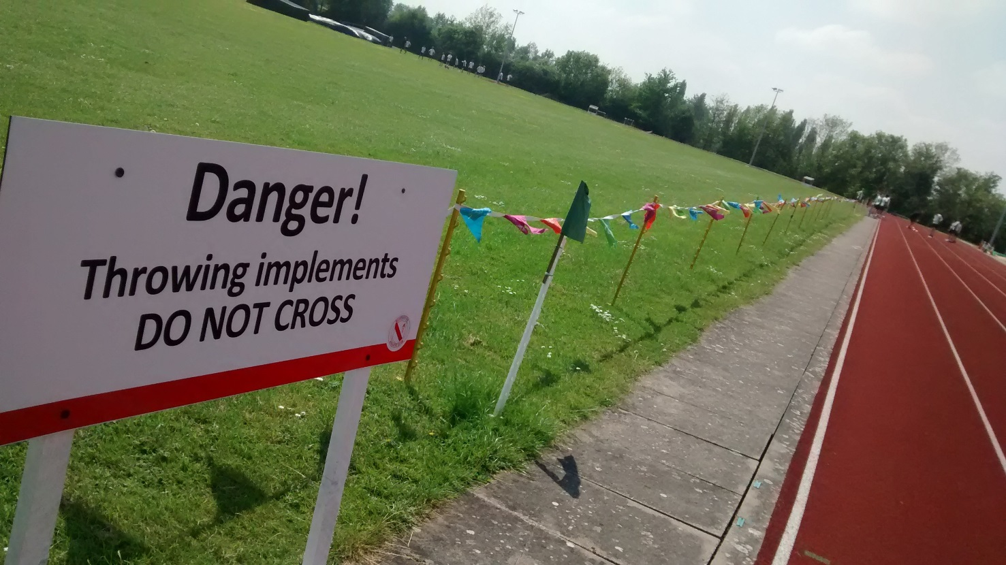

Top Tips
- Two or three pieces of advice they would give others if tackling similar issue
- Anything would they have done differently
Be pragmatic about the sort of legal tenure you can achieve as a new organisation without track record but aim for the longest lease you can get
Don’t take on the management of a facility unless you have the capital funding in place to bring it back up to standard
Make sure you have a good partnership with the Council and understand their needs
Make sure you understand your risks and liabilities and take a robust approach to risk management
Make the most of the media to tell your story and gain support
Don’t underestimate the amount of work involved

“Athletics is not an exclusive sport. We pride ourselves on being inclusive and diverse and one of the chief means of ensuring this is in keeping our costs low. ‘A pair of trainers and a front door’ has been said to be all that is needed to take part in Athletics. In practice, of course, it takes a little more but if we were to try to raise this sum of money from membership fees and track fees alone we are convinced that we would lose membership and restrict recruitment.”
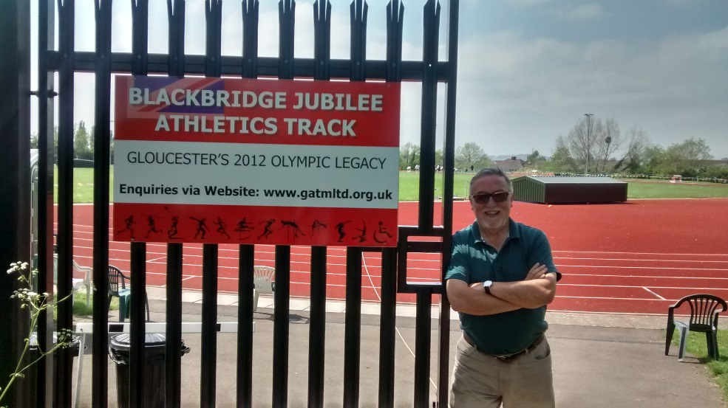

Case study contact details :
http://blackbridgejubileeathleticstrack.org.uk/

Key for Illustrations 01/02 (numbering or colouring + 1/2 word descriptions

Optional Illustration 02 if applicable - detailed B&W plan of key pitch layout with numbering & outline box or colour shading to key areas as per key but without / text / gridlines/references etc. Submission to include separate AutoCAD file for illustration with layers including separate layer for colour shading if used.
Include short caption up to c 8-10 words

