Nottingham City Gymnastics Club CIC
What this case study is about?
This case study tells the story of how a growing club with no base gained its own building through the asset transfer of an underused community centre, saving the Council money in managing the building whilst ensuring it continued to provide activities for the local community.
Sixways Community Centre is in the heart of the Broxtowe Estate in Nottingham. Nottingham Gymnastics Club has an inclusive, non-competitive ethos which focuses on children between the ages of 4 to 15, removing barriers to participation and enabling all abilities to have fun in sessions. The club has successfully engaged large numbers of local young people as well as being a draw for people from more affluent parts of the City.
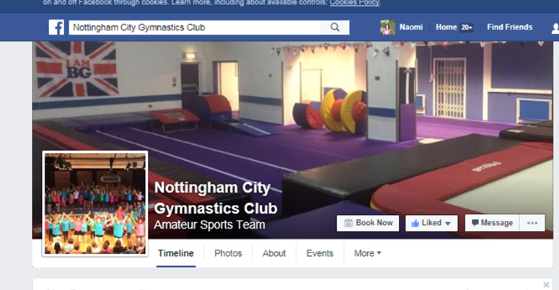

What was the problem?
Nottingham City Gymnastics Club was founded in 2009 and used a number of venues around the City, including schools and leisure centres. Over the next 5 years the club expanded its classes and grew to around 200 members training in 4 venues; three schools and a Leisure Centre.
Without dedicated space they were spending increased amounts of time setting up and putting away heavy equipment and they were limited in the number of sessions they could run. As a result they began searching for a space which they could grow into and develop the club, thereby providing more opportunities for young people, and adults, to try out gymnastics.

The club searched for their own facility for around 18 months, initially looking for an industrial unit, but had change of use planning applications rejected on two sites.
For Nottingham City Council there was a different problem. The Sixways centre in Denton Green, Broxtowe, was managed on behalf of the Council by the Broxtowe Partnership Trust, but the trust dissolved at the end of March 2013 and the centre closed.
The Council were keen to see it reopened and in April 2013 began advertising the Centre for asset transfer, however, this process was unsuccessful, possibly because it was done through a very formal contracting process which may have put off some community groups. The Centre was converted to a badminton court but in 2014 was only in use for one hour a week and otherwise was closed to the community.
What was the solution?
Looking for help and support, NCGC emailed their local councillor, to explain their vision and to ask if they knew of any facilities or spaces around the area. They were pointed in the direction of the City Council’s communities’ team, and the following day Sixways community centre - a mile away from their main venue - was identified. This was in November 2014.

Negotiations were led by the two club founders. After viewing the centre they met with the Deputy Leader of the Council, who was impressed enough to offer staff support and draft Heads of Terms for an asset transfer. From this point the rate of progress was extremely quick. With hindsight the group may have preferred a more formal approach with clear agreements, but recognise that the project might have become bogged down in bureaucracy and lost momentum. They did, however, have to submit a business plan as part of the formal process.

The Council were positive about their clear vision, business-like approach, risk analysis, commitment and obvious benefits to the local and wider community, which reflected many of the Council’s aims, but felt the club lacked experience in facility management. NCGG committed to undertaking training and over 12 months one of the Directors has been supported to complete the training needed to take on this role e.g. fire requirements, food hygiene, legionella. This reduced the Council’s main concern and they agreed to retain this responsibility for the first year until NCGC were ready to take it on. In addition, the club was not incorporated, so the two club leaders formed a Community Interest Company limited by shares as the legal vehicle to take on the lease. This legal form is not charitable but does ensure community benefit is core to the business and also ‘locks in’ the asset so that there is no private benefit available to Directors from the value of the lease.
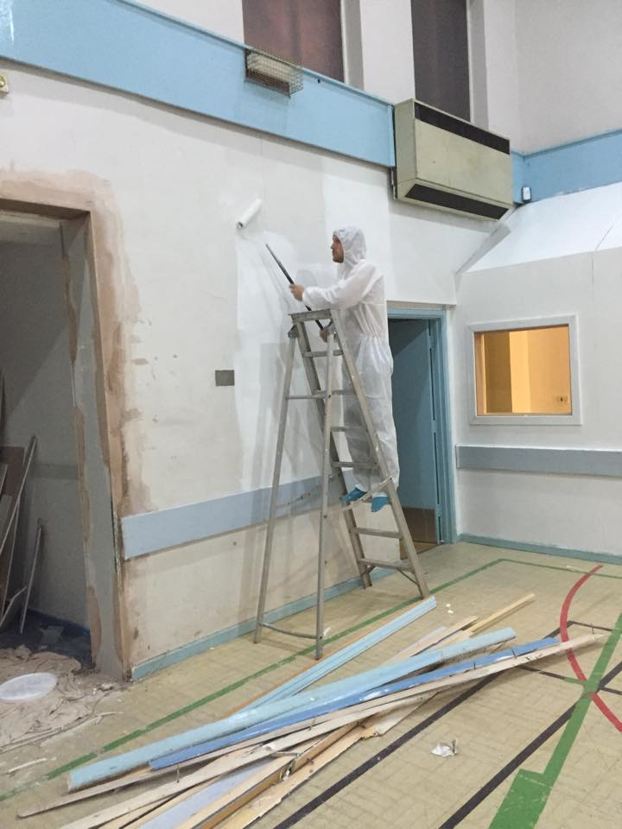
The centre needed work to make it fit for purpose. The Council agreed to complete outstanding maintenance pre-transfer at no cost to the club. The club raised £25,000 to transform the building into a dedicated gymnastics facility, with secure doors, and permanent mats and other equipment. They redesigned the space to meet their needs with reception/waiting/viewing area for parents and siblings, and a layout that allows users to change, warm up, do activities and leave the gym area all within a secure space. The £25,000 was made up of a £20,000 loan and £5,000 in fundraising. They did not seek capital funding from the Council or other funders as this would slow the process too much. The club managed the building project even though they didn’t yet have full security on the building, but felt it was a reasonable risk to take. The two leaders/Directors managed most of the work but volunteers and parents were vital and got involved in painting, cleaning, fundraising, and lots more.
In all it took 6 months for negotiations and then 3 months to opening. The Club got the keys for the facility in April 2015. Building work started in June 2015 and they started running sessions from July 2015. The Club took a risk in investing in the premises but due to the commitment and reassurance of the Council they felt it was a risk was worth taking. Ultimately, the Club got what they asked for - a long lease, permission to redesign the space, and the facility handed over in sound working order before the full repair lease began. Insurance and indemnity were bought through their British Gymnastics membership which provided significant savings.
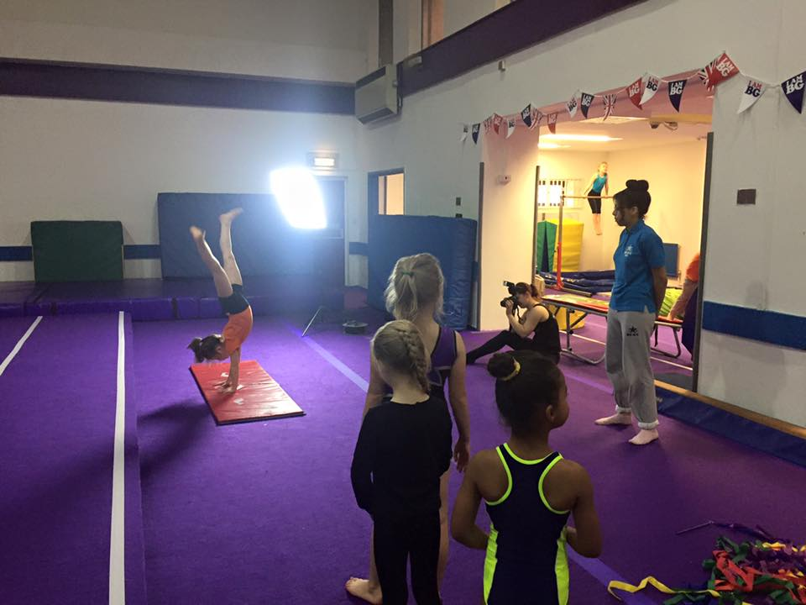
The final lease is a 30 year peppercorn, full repairing lease for the whole building and allows sub-letting.

What is the Business model?
The unique selling point of Nottingham City Gymnastic Club is that they are not a club which focuses on competition. They are all about participation and fun and high quality coaching. Their aim is ‘to create an environment where gymnasts of all ages, abilities, ethnicities and backgrounds can come together and enjoy gymnastics in a safe, effective and child friendly environment.’
This has helped the club to grow steadily and now more than 400 members pay a monthly membership fee of between £13.50 and £45 per month for young people (working out at less than £3 per hour for most participants.) Monthly fees for adults are £17/month for a weekly session. Fees are usually paid via standing order over 12 months, based on classes running 40 weeks of the year. All members require insurance at £17 annually, paid when joining.
A paid membership of 250 makes the club sustainable. Over and above this are “pay-as-you-go” pre-school sessions and home-schooling sessions to make use of daytime capacity, holiday clubs, parties and branded club tops. The City Council also gave 2 years of funding for some free places for local children from the Estate.
The Club use an online management system called https://www.class4kids.co.uk/ to manage waiting lists, enquiries, fees and other processes. It attracts around 30 weekly enquiries and is a source of new members, as well as word of mouth with minimal marketing.
There are paid coaches and young leaders and volunteers. There are no other paid staff. Financially they are doing well and are ahead of schedule in repaying their loan but they are now responsible for all costs and utilities. All coaches and young leaders are paid and staffing costs are approximately £450 per month including all associated costs including PAYE and tax. Other main costs include utilities, insurance, and equipment replacement. They are in the process of applying for rate relief.

What was the result?
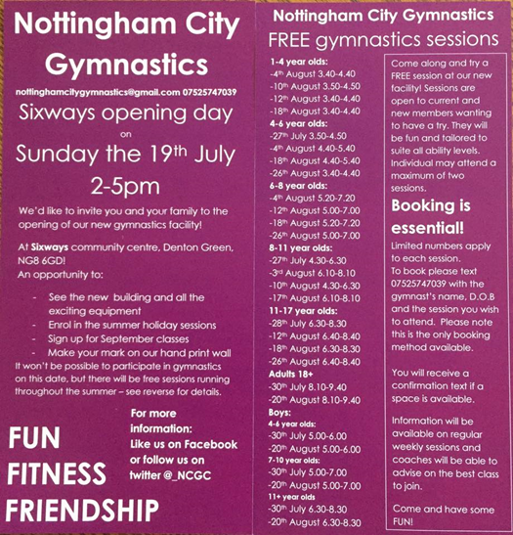
The City Council is saving revenue and maintenance costs and has brought a community centre back into use.
The Club has control of their space, security of tenure and the opportunity to continue growing the business in a sustainable manner. Club membership has doubled.
The Centre is very well used and footfall is now over 650 per week. They are continually looking for ways to use spare capacity, such as home-school session. More young people and adults are active and enjoying sport. They are particularly successful with teenagers, a difficult group to engage in sport.
For the future, the centre will provide more opportunities, with possible dance classes for parents whilst waiting for children, and running themed children’s parties. There is also the possibility of sub- letting some space to related organisations. They are aiming for 1,000 users per week.
The Club has been successful in attracting local people, raising aspirations and helping to overcome negative perceptions about the area.
Through Facebook, the parent’s network and the reception area they engage parents very effectively. They attend local community events and will be working with other sports groups to further increase participation. They have quickly built up trust and the community feel their views are being taken forward. For example, a Boys Night has been set up due to working with some lads who requested a session. Two now have coaching certificates and quite different aspirations
A number of users have taken up gymnastic coaching courses. Some parents have also started to volunteer and gain skills ad confidence, staff have had training on level 2 coaching courses.

Top Tips
Be positive, talk to people who have done it, learn, know your risks and manage them.
The online class management system saves hours of time. They couldn't run the facility using old paper methods.
Social media is a vital tool for marketing and engagement but face to face engagement is also crucial. NCGC ran over 30 free taster sessions throughout the summer, giving local people a chance to try before signing up. Every new joiner has the opportunity to try two sessions before they enrol. As a result of feedback they have introduced new affordable sessions which will appeal to local people.
British Gymnastics provided helpful information and support. Always contact your sport governing body to see how they can help.
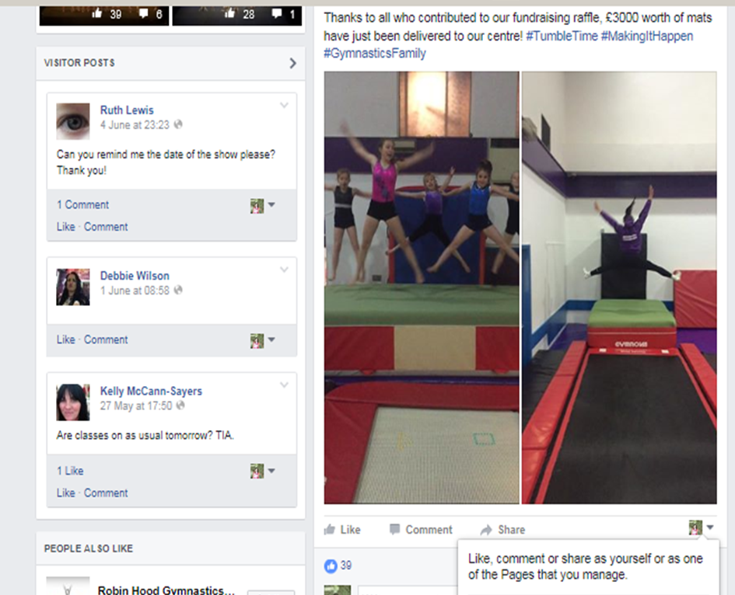
Case study contact details www.nottinghamcitygymnastics.co.uk/

