

**Protecting Playing Fields**

**Application Guide**

**Round 8**

**14 September 2015 to 5pm on 9 November 2015**

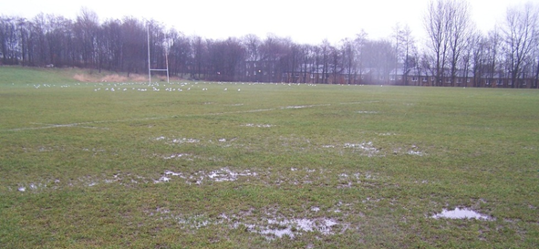

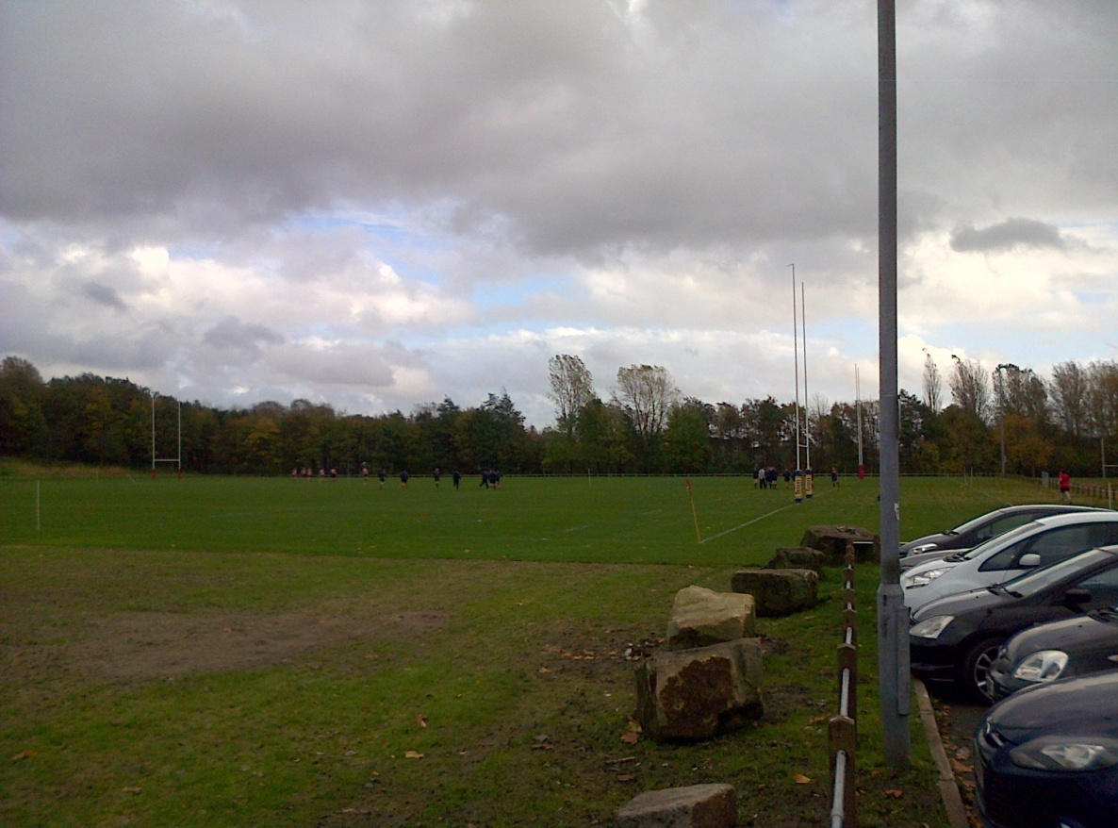

**Protecting Playing Fields Funding Programme**

**Playing fields are one of the most important local resources for sport in England but many of them become waterlogged or in a state of disrepair, so we are investing £33 million of National Lottery funding into improving community sports fields.**

The Protecting Playing Fields funding programme is part of [Sport England’s strategy](http://www.sportengland.org/about_us/what_we_do.aspx) which is focused on helping more people acquire lifelong sporting habits. It will invest in capital projects to either create new natural turf pitches or improve existing ones that need leveling or drainage works.  The programme is being delivered via funding rounds with approximately £3 million allocated to Round 8. The first seven rounds of funding have benefited 439 projects.

**Round 8 will open on 14 September 2015 and close on 9 November 2015.**

**Round 9 will open in the Autumn of 2016**

Initial decisions on applications received in Round 8 will be made in February 2016. This guide and the FAQs will provide all you need to find out more about Protecting Playing Fields including how to apply, how your application will be assessed and what we're looking for.

First, we recommend that you complete the self-assessment checklist which will give you a quick indication of whether Protecting Playing Fields is the right programme for you. There is a checklist for different types of organisation, such as local authorities, education establishments and community or voluntary organisations to download from the [website](http://www.sportengland.org/funding/our-different-funds/protecting-playing-fields/).

**Sport England requires a legal charge (or restriction on title for local authorities) over the playing pitch land as a form of security for 25 years on the investment on successful projects BEFORE work starts on site.**

**This means that the charge MUST be in place and registered at HM Land Registry (and where relevant, at Companies House) before any physical work can begin on your pitch(es).**

**To enable the charge or restriction to be in place and registered in time for your project to start at the earliest time, successful projects will need to instruct their solicitor to carry out this work as soon as the award offer is accepted. It is advised that you check your lease or freehold document to ensure there is no reason why the charge or restriction cannot be put in place. You may also want to check your organisation will consent to this requirement.**

**Further information about grant security is provided in our FAQs.**

**Aims of the funding programme**

The aim of the fund is to create, develop and improve natural turf playing fields for community sport and offer long term protection of the site for sport. We believe that the improvement and protection of playing fields will help retain participants and achieve sustainable increases in participation.

Successful projects will be those which can demonstrate future management, maintenance and sporting use at the site along with the site being protected for 25 years or longer. This means that organisations must own (or intend to own) the freehold or have a lease for the field for that length of time from the date of the award.

We are also particularly keen to improve and protect playing fields in community ownership. As such we will also look to provide further support to those where ownership of playing fields sites is being transferred to the community from public ownership.

**Why protect playing fields?**

There are over 64,765 playing pitches at 19,411sites in England. They provide the valuable space required to maintain and enhance opportunities for people to participate in both formal team sports and other more informal activities.

Along with sporting benefits, good quality accessible playing fields can also contribute to the creation of healthy and active communities to secure wide-reaching benefits.

**Sport England’s statutory role**

Sport England has been a statutory consultee on planning applications affecting playing field land since 1996. On average we receive around 1,300 planning application consultations a year.

We believe that the best way to protect and enhance playing fields is for all local authorities to have a robust and up to date Playing Pitch Strategy (PPS), backed up by appropriate management and maintenance arrangements.

This is why an up-to-date PPS is a fundamental requirement upon which local authority applications need to be based (see FAQ 9).

Further information on Sport England’s statutory consultee status and the development of Playing Pitch Strategies can be found on our website via the below links:

[Statutory consultee status](http://www.sportengland.org/facilities-planning/planning-for-sport/development-management/planning-applications/playing-field-land/)

[Playing pitch strategies](http://www.sportengland.org/facilities-planning/planning-for-sport/planning-tools-and-guidance/playing-pitch-strategy-guidance/)

**Fields in Trust**

Sport England has an on-going partnership with national charity Fields in Trust (FIT) to support the long term protection of playing fields.

Successful applicants to the PPF programme who want to protect their playing field in perpetuity via a Deed of Dedication will have their project details passed to FIT to undertake the registration.

Further information can be found at [www.fieldsintrust.org/safeguard.aspx](http://www.fieldsintrust.org/safeguard.aspx)

**Key features of the programme**

PPF has a number of key features and it is important that these are understood by any organisation considering applying for funding to the programme:

* Applicants must be able to give strong written evidence of the **need** for the project
* Projects must be **community** led and demonstrate strong local partnerships
* Applicants must demonstrate the **impact** the project will make on sports development
* Successful projects will be those which demonstrate strong **sustainability** through future plans for management, maintenance and marketing for sporting use at the site

* Successful organisations must offer protection of the site by providing a form of security over the grant investment by way of executing a legal charge on the site for a minimum of 25 years. **The charge must be in place prior to work starting on site**.
* Successful organisations can receive support with the design, specification and delivery of the capital works aspect of projects from our turf specialists. The turf specialists will also arrange for the procurement and contract management of capital works to be undertaken on your behalf. We hope that this will greatly reduce the administrative burden on successful projects and enable them to focus on sports development and sustaining the project. There are more details in the ‘How to Apply’ section
* Playing fields for which funding is being sought will need to have been identified through either a published Playing Pitch Strategy, adopted Local Development Plan or local assessment of need
* Education and Statutory applicants, such as local authorities (excluding parish and town councils) must provide partnership funding

**Programme Criteria**

This is a competitive investment programme and we are likely to receive applications for more projects than we are able to fund. All applications will be assessed against two sets of criteria and only those that best meet the criteria will be supported:

* Is the project eligible for this fund?
* What impact will the project make on the programme aims and Sport England’s strategic outcomes?

**Priority Applications**

Priority will be given to projects that:

* Have not previously received an individual Sport England Lottery grant worth over £10,000
* Involve playing field sites where there is a known and established threat to the land. For example, where playing fields have been mothballed, fenced off and/or pitches ceased to be marked out for over two years; planning application submitted for development or land offered for sale
* Are located in Greater London
* Form part of an asset transfer of the playing field from the public sector to the community and voluntary sector. More information on asset transfer can be found at [here](http://www.sportengland.org/facilities-planning/tools-guidance/asset-transfer/)
* Are multi-sport (two or more sports pitches such as a winter and summer sport) or have multiple pitches for the same sport

**Low Priority Applications**

We are less likely to fund:

* Projects for only one sport and one pitch
* Projects for training areas only
* Education establishments which do not provide adequate changing accommodation on site for the use of community teams as part of a pitch hire agreement
* Applications for playing pitches used by professional or semi-professional clubs unless significant (80%) use on the playing field(s) is grassroots participation

**How to apply**

There are four simple steps to applying for a Protecting Playing Fields grant:

1. Check your organisation and project is eligible
2. Find out if the project meets the programme aims and criteria
3. Work out your project costs
4. Complete the online application

**Step 1: Check your organisation and project is eligible**

Eligibility is dependent both on the type of organisation applying and the aims and type of projects. Applications need to meet the following criteria to be eligible for the Protecting Playing Fields Fund:

* Be submitted by an organisation entitled to receive public lottery funding such as sports clubs, playing field associations, voluntary or community groups, local authorities and education establishments
* Be for one of the following:
* the purchase of land for new playing fields and bringing disused playing fields back in to use **or**
* the purchase of playing field land where there is a known or established threat, such as the expiry of a lease or a development proposal **or**
* Improvements to existing pitches through levelling, drainage and associated pitch remediation works

Please note that projects to only carry out enhanced maintenance works will not be eligible

* Be for a single site where the applicant holds or will hold the freehold or a long term lease before work starts on site. The lease will need to have at least 25 years remaining. See FAQ 1 for further information
* Offer protection of the site by providing a form of security over the investment in the form of a legal charge on the site for a minimum of 25 years before work starts on site
* Request a grant of between £10,000 and £65,000, except Local Authorities, who can apply for between £10,000 and £100,000
* Local Authority applicants are required to provide matched funding on a £:£ basis. The maximum Sport England award will be 50% of the total project cost
* Education establishments, such as schools, colleges or universities, will need a minimum of 30% partnership funding towards the total project cost
* Request funding for a capital project which has not yet started on site
* Not include equipment or revenue costs as these are not covered by the fund
* Involves football, cricket, rugby league, rugby union, softball/baseball, American football, Gaelic football, Australian rules football, hockey, hurling, lacrosse, polo, rounder’s and archery
* Benefit players who are adults and/or young people aged 14 and over
* Be at least 0.2 hectares for projects creating new playing field land
* Be the only application submitted by the organisation in this round
* Add value to community sport and not duplicate or substitute statutory funding. Please see our [full additionality statement](http://www.sportengland.org/funding/about-our-funding/the-way-we-fund/).
* Demonstrate the project can be complete and the pitch in use within two years from the date an award is offered.

**Step 2: Find out if the project meets the programme aims and criteria**

We assess all eligible applications against four criteria:

1. Strategic and local need
2. Community involvement
3. Impact on sports development
4. Sustainability

**Assessment Criteria 1 - Strategic and local need**

Applications must show clearly that there is a deficiency in terms of quantity, quality and/or accessibility of community playing pitch provision in the local area and demonstrate clearly that the project will help to address this deficiency.

For projects providing new playing field land, we are looking for

* evidence of the need for more pitches **and**
* evidence that the pitches are needed in this location

For projects to improve an existing playing field, we are seeking

* evidence that the pitch is still needed **and**
* evidence to support why it needs improving

The nature of the information you need to provide in support of your application will differ depending on whether you are

* a local authority
* an education establishment
* voluntary sector organisation (including town and parish councils)

Local Authorities

Applications from Local Authorities must show how the project meets an identified need in a robust, up to date and published Playing Pitch Strategy (PPS) or adopted Local Development Plan (LDP) for their area.

Applications supported by a PPS identifying the project as one of the top priorities in the action plan will be a higher priority than an application supported by a PPS which does not.

Educational Establishments

Applications from Educational Establishments should provide evidence to show how the project meets an identified community need in the local area. This could include references in the local authority’s Playing Pitch Strategy (PPS) or adopted Local Development Plan (LDP) to deficiencies in the quantity, quality and/or accessibility of playing pitches in the local area and/or direct reference to the need for the particular project.

If there is no up to date, published strategic document such as a PPS, then applicants should undertake and evidence a local assessment of need. More information on this can be found in FAQ 9.

A strong application will also provide details on the quality of the pitch(es) and their current use; data on the number of occasions training and fixtures were cancelled, along with letters of support from the relevant league(s), referees, coaches, NGBs, local authority and other stakeholders. Photographs that support the need for improvements can also be provided to strengthen the case for investment. See FAQ 9 for further information.

Community and Voluntary Sector Organisations

Community and voluntary sector organisations should also check to see if their local authority has an up to date and published Playing Pitch Strategy (PPS) or adopted Local Development Plan (LDP). Where this is the case, applications should show how the strategy identifies deficiencies in the quantity, quality and/or accessibility of playing pitches in the local area and/or makes direct reference to the need for the project.

Where there is no strategy or the strategy does not provide sufficient detail for a particular site, applicants will have a greater chance of success if they demonstrate how the project meets an identified local need through consultation with clubs and players that currently use, formerly used or would use the site if improvements were made.

A strong application will also provide details on the quality of the pitch(es) and their current use; data on the number of occasions training and fixtures were cancelled, along with letters of support from the relevant league(s), referees, coaches, NGBs, local authority and other stakeholders. Photographs that support the need for improvements can also be provided to strengthen the case for investment. See FAQ 9 for further information.

**Assessment criteria 2 - Community-led and partnerships created**

Applications must demonstrate that the project has been developed in consultation with the community and that partnerships have been created.

Fully involving the community in the project is an important part of both the initial development and long term sustainability of any community sport project. Partnership building is about working with other people and organisations to make the project a success.

Good applications will provide clear evidence of:

* Community consultation, involvement and support for the project
* Established partnership working between the organisations involved which will last beyond the lifetime of this application

Identified groups of people such as neighbours, potential users and the wider community who may provide volunteers, future spectators and fundraisers.

**Assessment Criteria 3 – Impact: contribution to sports development**

Applications should clearly explain how the proposed investment will contribute to improved outcomes for sport. The application should be supported by a sports development plan to explain how the sporting outcomes will be delivered.

Good applications will provide clear evidence of:

* Sporting benefits the project will achieve
* Clear project outcomes including an explanation of how they will be delivered and achieved
* Measurable outcomes and success indicators that illustrate value for Sport England’s investment.

**Assessment Criteria 4 - Sustainability**

Applications should show how the site will be managed, maintained and marketed to safeguard the investment. We ask you to complete an income and expenditure forecast for the next three years to support your application.

On-going community engagement is an important part of the sustainability of any community sport project. This has the potential to reduce costs and generate greater community ownership of the facility.

Good applications will provide clear evidence of:

* A simple income and expenditure forecast for 3 years. To help you with this we have provided a template for you to use
* How you will cover the annual ongoing management and maintenance costs of the new or improved pitch
* Funding from other sources already obtained or confirmed in writing
* Engaging other community organisations – schools, clubs, media, neighbourhood office, etc
* How our funding will facilitate a genuinely sustainable local community sports playing field.

**Step 3: Work out your project costs**

A key feature of this programme is the support that will be made available to successful applicants.

Through our turf specialists we will offer applicants the opportunity for all phases of the project to be managed on their behalf, from initial site investigation through to construction and completion of the works.

We have already tested the market to obtain estimates of the cost of various pitch works and would like you to use these costs in your application. There are Budget Cost information sheets for typical capital pitch improvements on the website that will help you assess both the type and cost of works you need. The Budget Cost sheets also provide information on the typical initial grounds maintenance costs which will need to be covered in the first year following the improvement works and the ongoing annual maintenance costs required to keep the pitch in good condition.

If you have developed your own costs for your pitch project then please use those in your application. For example, if you have undertaken a site survey or feasibility study in the last 3 years then please upload this with your application. If however, you have no cost information then please use the Budget Cost information sheets available on the website.

If your application is successful you will receive a visit from a Sport England turf specialist who will carry out a technical assessment to confirm the cost of your project (unless you have a recent feasibility study which meets our requirements). The cost of the turf specialist must be included in your project budget.

You should also include the cost of the legal fees for the grant security process (Sport England can contribute up to £1,000 of the award towards this) and Sport England signage (£100).

You need to include all non-recoverable VAT in the project budget. If you are unsure if your organisation is able to recover all, or a proportion, of the VAT you will pay on this project, you should consult with HM Revenue and Customs.

Projects with partnership funding confirmed should include written evidence with the application. FAQ 7 and 8 provide further information about partnership funding and what in-kind costs are acceptable.

**Step 4: Complete the online application**

If your project is able to deliver on the programme’s aims and meets the eligibility and assessment criteria of the fund, you can apply online at [My Applications](https://enquiry.sportengland.org/applicationportal/login/applicationlogin.aspx) on the Sport England website [www.sportengland.org](http://www.sportengland.org)

**Application Form**

The Protecting Playing Fields application form can be found at [My Applications](https://enquiry.sportengland.org/applicationportal/login/applicationlogin.aspx) and must be submitted online.

If you have not applied to Sport England for funding before you will need to register your organisation. You will be prompted to do this as you start your application. Please note that the organisation name you register must match exactly the name as it appears on your governing document, the lease or freehold document and other supporting documents.

Guidance is provided on every page of the application form on the right hand side of each page. This guidance will explain in more detail how to complete each section and what information is required. It will also refer you back to this guide for some explanations.

Question specific guidance can be found by simply clicking the [Help](javascript:;) next to the question. Further guidance is provided to explain why the question is being asked and help to answer the question.

If the online support does not provide a suitable explanation to enable you to answer the question a Funding Helpline is available.

The helpline number is **03458 508 508** and you will be put through to a Sport England officer who will be able to answer any questions you have. The opening hours are Monday 8am to 9pm, Tuesday to Thursday 8am to 6pm, Friday 8am to 5pm.

Alternatively you can email for assistance using [funding@sportengland.org](mailto:funding@sportengland.org)

The application form has a series of pages to complete. Please do not forget to save as you go along. You should only submit the application when you have checked it is complete with all the supporting documents.

**Documents you need to submit to support your application**

We need you to provide two types of document with your application:

* Governance and ownership documents
* Project specific documents

**Governance and ownership documents**

These provide information about your organisation which we need to see to determine whether it is able to receive Lottery funding from this programme. We also need to consider the financial health of your organisation and how it is run and managed.

The documents we need to see with your application are:

* A copy of the governing document. For example, this may be a constitution, memorandum and articles of association, trust deed or other formal document (not required for statutory bodies)
* A copy of most recent audited or verified accounts (not required for statutory bodies)
* Copies of bank statements for the last three months (not required for statutory bodies)
* Evidence of security of tenure (freehold title document or lease with at least 25 years remaining)
* Child protection policy (for projects involving children)

**Project specific documents**

These documents help you to provide us with a picture of how your project will deliver the outcomes shown in your application and whether the project is sustainable.

The documents regarding your project which we need to see are:

* Sports development plan
* Income and expenditure forecast for a minimum of three years

We have provided templates for the sports development plan and income and expenditure forecast for you to use if you wish. These are available [on our website](http://www.sportengland.org/funding/protecting_playing_fields.aspx). If you already have this information in another format you can upload them to your application.

Where relevant, you should also include supporting evidence of

* Partnership funding confirmed
* Any existing feasibility or pitch condition reports
* Strategic documents such as a Playing Pitch Strategy or Local Development Plan

Please note - your application is only deemed complete when we have received all of your supporting documents. The deadline date for submission of your supporting documents is **5pm on Monday 9 November 2015.** Please upload your supporting documents below before clicking the submit button. Alternatively you can email them to us at [funding@sportengland.org](mailto:funding@sportengland.org). Please remember to quote your URN on all emails. If you need any assistance please call our funding helpline on 03458 508 508.

**Decisions**

Sport England’s Project Committee will make the final funding decisions. You will be notified of their decision in writing and by telephone once the outcome has been confirmed.

We expect to receive a significant number of applications so some will be unsuccessful. If we cannot fund your project we will write to you and explain why.

Successful applicants will be offered a conditional award which is subject to technical assessments and confirmation of costs. You will be fully briefed on the next steps by your Grant Manager. This will include an explanation of all funding paperwork and reporting requirements. A key element will also be the roles and responsibilities of parties in terms of working with the Sport England appointed turf specialists.

This phase will be very different to capital programmes that Sport England has previously run. In most cases, the technical and construction elements of the project will be managed by our turf specialists including the site investigations, specification, tendering, procurement and construction phases.

**Measurement and evaluation**

To ensure the investment made is delivering the agreed outputs and outcomes we will monitor all projects.

We are required to demonstrate that the Lottery grant has been used for the purposes for which it was awarded and so we will need you to measure the amount of sporting activity being achieved.

We therefore expect successful applicants to monitor the use of the facilities and provide us with data on activity levels at six monthly intervals for five years through our online reporting tool.

**Further Information**

For further information and queries please contact Sport England Funding Helpline on **03458 508 508** or email funding@sportengland.org