Methodology of measuring sports participation
Consultation response
December 2015

Contents
Executive summary 3
Introduction 4
Consultation findings 5
Implementation plan 10
What will this mean for me? 15
Quality commitment 16
Appendix1: Respondent breakdown 17
Appendix2: Local sample boosts 18

Executive summary
Between August and October 2015, Sport England consulted stakeholders on the methodology of measuring sports participation. There was a good level of response from a wide range of stakeholders.

Support for proposals:
Overall, the responses we received from the consultation were extremely positive, with the vast majority supportive of the proposal
- 98% of stakeholders responding to the consultation were either wholly or broadly supportive of the proposed change
- There were high levels of support for capturing key demographic characteristics, geographic data, and sport specific data
- Over 90% of responses agreed that the new arrangements should be implemented for an initial period of 5 years, and that the new survey should run alongside the Active People Survey (APS) until March 2016

What we have implemented:
- A mixed-mode self-completion design involving online (including smart phone) and paper methods has been chosen as the new survey methodology
- Participation is being tracked at a population level by demographic group, geography and activity
- The overall sample size will be 198,250 people each year. The minimum annual sample size for each English local authority will be 500, with additional boosting in some local areas

Timings:
- The new survey went to field in November 2015, and will run for an initial period of 5 years
- APS will also continue to run until 30th September 2016

Introduction
Sport England is an insight-led organisation tasked with getting more people active. To create the right conditions for this we need a broad and deep knowledge of how much sport people play, what sports they play and which sports they’re interested in playing more of. This will inform our decisions around who we invest in, and our understanding of how sport can deliver wider objectives.

Through our commitment to measuring sports participation over the past decade, we have unparalleled data both internationally and amongst other sporting and cultural agencies in the UK. Central to this commitment has been Sport England’s APS. APS has existed since 2005/06 and over that time, its design has remained largely unchanged. The cross sectional, random digit dial (RDD), landline telephone design has provided an effective mechanism to measure a wide range of sports and provide local authority level data.

However, given changing patterns of telephone use, surveys based purely on residential landlines no longer have complete or even coverage of the target population. Whilst all of the validation, testing and development we have undertaken gives us confidence the current design remains fit for purpose, changes to our business requirements and the changing use of technology mean new and alternative approaches should be considered as we look to ensure the right arrangements are in place for the next 5-15 years.

Having previously consulted users of APS data about modernising the survey design in 2013/14, we have noted considerable support for the introduction of a new survey design. In response to the 2013/14 consultation, Sport England carried out further testing of different modes of data collection. We learnt a great deal from this work and are now confident there are alternative survey designs that can effectively meet our objectives and requirements.

So as Sport England considers its strategic priorities for the period until 2021, we remain committed to continue to lead in this area, and believe there is now a natural opportunity to review both what we measure (to ensure it aligns with the Government’s, and our own, new strategy) and how we measure it (reflecting the best available methods). Please note, the recent methodology consultation and this response to it are specifically concerned with the collection of data. In parallel, DCMS have undertaken a wider consultation to establish the strategic priorities for community sport.

Based on what we have learnt from the pilot studies, and the views expressed through both consultations, we believe it is now the right time to implement plans (approach and timing) for the future measurement of sports participation. This report presents the views expressed by users of APS data and other stakeholders and the action we are taking.

Consultation findings
The consultation ran from 19 Aug 2015 until 14 Oct 2015. In total, 346 responses to the consultation were received. Appendix 1 provides more detail on the type and range of organisations that responded. We are very pleased with the high number and range of responses and grateful to everyone who took the time to respond.

Proposed change
All 346 respondents expressed a view about developing a new methodology for measuring sports participation, with overwhelming support for change.

98% of respondents (338/346) were either wholly or broadly supportive of change

There is agreement amongst stakeholders that whilst the Active People Survey has been valuable in providing a consistent approach to measuring participation over the past ten years, a new methodology is required in order to reflect changes in technology and communication.

Survey design
Of the proposed survey designs, the dual-frame (mobile and landline) telephone design was favoured by 34% of respondents, followed by the online (postal-to-web) design favoured by 28% of respondents. A further 20% of respondents expressed no preference, with the remaining 18% supporting another survey design.

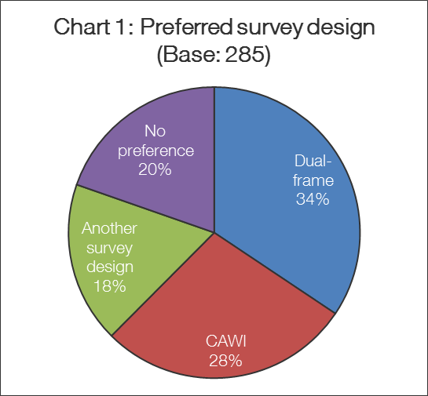

Of those respondents expressing support for another survey design, alternative suggestions included:
- The use of focus groups
- Sending survey links via text
- Using social media and apps
- Using a mixture of methods (most commonly incorporating both the online and telephone data collection)

Respondents who expressed no preference were generally happy to support whichever design achieved the most demographically representative sample, with an emphasis on reaching groups that may have been previously underrepresented.

When asked about the importance of different aspects of survey design and quality, high levels of importance (greater than 90% rating them essential or important) were placed on all of the factors identified:

Table 1: How important are the following? (Base: 285) | Essential/Important
Simplicity & transparency | 96%
Minimising the burden on respondents | 95%
A design that will remain fit for purpose over the long term | 93%
High quality statistical methods and principles quality  assured by professional statisticians | 93%

Measurement priorities
Demographic data
Over 95% of responses said it was either essential or important that information about gender, age and disability are collected. Whilst not given quite the same level of importance, more than 75% of responses felt it was either essential or important to capture information about ethnicity, social grade and employment status. The majority of responses also rated the capture of information about education and household structure as essential or important. Capturing data about faith and sexual orientation was considered less important but as protected characteristics we believe it is still necessary to collect this information.

A small number of respondents also expressed a desire to extend the age range of the survey in order to gain greater understanding of participation habits amongst children under the age of 14 years old.

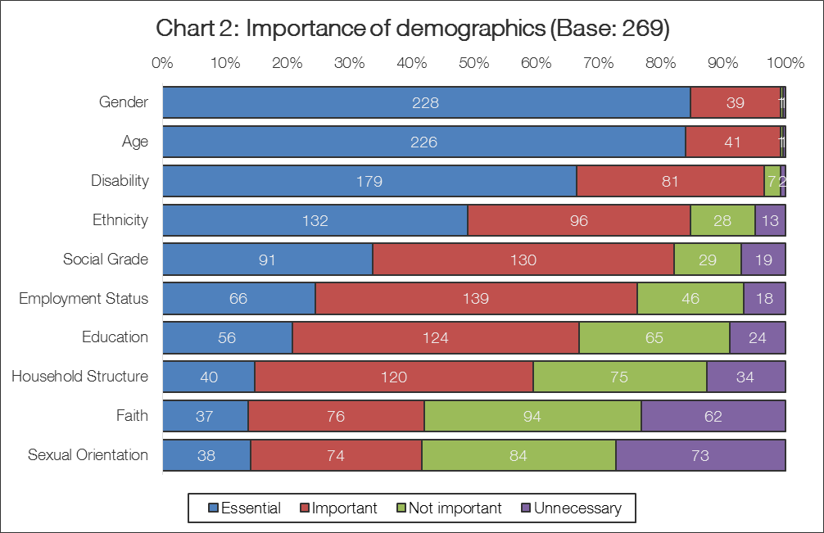

Geographic data
When asked about the importance of different levels of geographic data, high levels of importance (greater than 80% rating them essential or important) were placed on the provision of regional, County Sport Partnership (CSP) and local authority level data. The importance placed on local authority level data was particularly high (94%).

Table 2: How important is it that sports participation is tracked at a geographic level by: (Base: 265) | Essential/Important
Region | 87%
CSP | 83%
Local Authority | 94%

Related to the importance placed on local authority level data, some respondents expressed a desire for larger local sample sizes to improve the stability and precision of survey estimates.

Understanding sports participation
When asked about the importance of different types of data to help understand sports participation, high levels of importance (greater than 85% rating them essential or important) were placed on all of the factors identified. The highest levels of importance were placed on capturing sport specific data and information about the nature of sporting engagement (including how different activities combine as part of an active lifestyle).

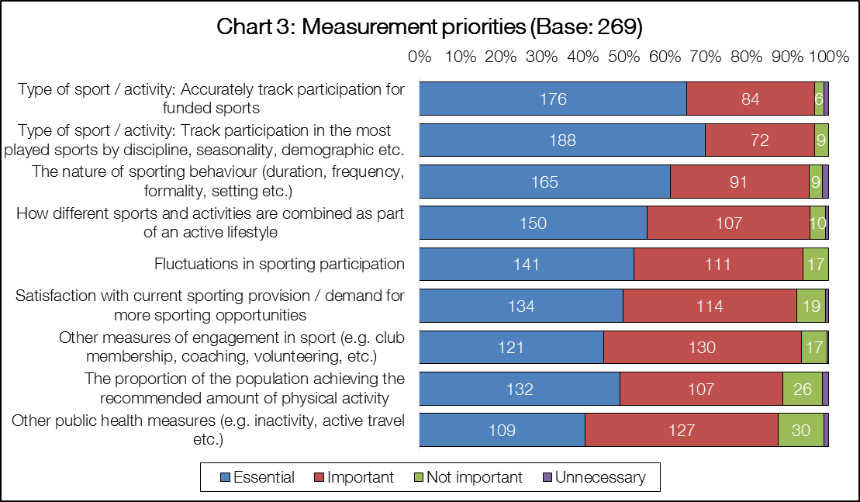

Proposed timings
Parallel running
The vast majority of respondents agree with the proposal to run the new survey in parallel with APS in order to ensure a smooth transition (90% answered that they completely agree or broadly agree).

Whilst there is agreement with the parallel running of APS and the new survey, some concerns were expressed that the proposed period of parallel running was too short. Respondents suggested that the two surveys should be run alongside each other for an entire year rather than just six months.

Length of contract
96% of those who answered the consultation are supportive (answering completely agree or broadly agree) of implementing the new survey for an initial period of 5 years (until 2020/21), to cover the next strategic and Whole Sport Plan funding cycle.

Respondents are keen that arrangements are long enough to establish a consistent time series. Indeed, views were expressed that five years should be seen as a minimum and ideally a 10 year commitment should be made. However, other respondents felt that likely changes in technology over a five year period should mean arrangements are reviewed more regularly.

Other views expressed
At the end of the consultation questionnaire, respondents were given the opportunity to raise any other points they felt were of importance. The views expressed included:

Continuity of time series data
Whilst support for the introduction of a new survey design is extremely high, in common with some of the views expressed in the 2013/14 consultation, a small number of respondents also emphasised a desire to retain the consistency of any new data with previous results.

Greater triangulation of survey data with other data sources
Views were expressed that there should be greater triangulation of data from the new survey with other data sources (including NGB data sources, personal tracking data, gym / facilities data).

Greater access to survey data and support with analysis and interpretation
Views were expressed that there should be greater access to the survey data and that consideration should be given to how key stakeholders might be supported with analysis and interpretation of the data.

Implementation plan
As outlined in the consultation document, Sport England has been working to appoint an appropriate social research agency to develop and implement the new arrangements to measure sports participation. We have appointed the leading social research agency, Ipsos MORI, to work with us on this project. Their appointment will be for a five year period that will cover both Sport England’s 2016/21 strategy period and the 2017/21 Whole Sport Plan funding cycle. We believe the five year contract will provide the right level of stability and consistency but coupled with a commitment to ongoing innovation (see commitment to innovation section, page 14) will also ensure the new survey is futureproofed and remains at the forefront of social research.

Survey design
Having reflected on the findings of the consultation, and also the views of a range of leading social research agencies selected for consideration as potential suppliers for the new survey, we have decided that the new survey will have an online (postal to web) design. Whilst not the most popular survey design option amongst respondents to the consultation, it did receive considerable support and we believe it is the best choice for the following reasons:

- In common with the dual-frame telephone design, the online design will deliver a more balanced sample profile than APS reducing the extent to which data will need to be weighted
- The survey sample will be selected from the Royal Mail’s Postal Address File (generally regarded as the “Gold Standard” for population surveys)
- The postal to web design will enable precise geographic targeting of local samples
- The development of a “device agnostic” questionnaire will give respondents the broadest range of options possible for completion of the questionnaire (PC, laptop, tablet or smart phone as well as a paper survey for offline households)
- The development of an online questionnaire presents exciting opportunities for new and innovative approaches to question design
- The online survey design is not vulnerable to changing patterns in the ownership and use of landline and mobile telephony
- The online survey design is significantly more cost effective than telephone data collection

More complex multi-mode designs have not been pursued because the challenges presented by combining different sampling frames and modes of data collection (interviewer led and self-completion) within a single survey design would not result in a simple and transparent survey (a clear priority expressed by those responding to the consultation). However, we will be implementing some suggestions put forward in the consultation, such as using SMS text inks to access the survey questionnaire.

Measurement priorities
The cost effective design will support the accurate tracking of regular participation at a population level, by:

- Demographic group (age, disability, gender, ethnicity, socioeconomic status, working / educational status, faith, sexuality, other demographics)
- Geography (national, regional, CSP and local authority)
- Sport / activity (providing accurate and precise estimates of regular participation for a range of specific sports and activities, including additional detail about specific disciplines for major sports)

This is possible through the development of online and postal questionnaires that take approximately 15 minutes to complete and an annual survey sample of 198,250 respondents.

At this stage, we will not be extending the age range of the survey below 14 years of age. However, arrangements for measuring participation amongst younger people will be reviewed in response to the new strategy for sport. Extending the age range covered by the new survey (as suggested by some consultation responses) is an option for consideration but depending on the requirements set out in the new strategy we believe it may be appropriate to also consider other alternatives before committing to a particular course of action.

The new survey is being conducted on a very large scale and will represent a huge commitment from Sport England. The minimum annual sample size for each English local authority will be 500 and continue to provide robust local estimates (the same as APS). However, in response to comments about the need for larger local sample sizes, we believe there is some scope to improve the precision and stability of estimates by boosting the sample size in a number of local areas. Larger sample sizes also enable more local demographic and sport specific reporting.

For the first year of the survey, local samples are being boosted on the following basis:

- The eight English Core Cities are having their sample boosted to 2,000 respondents
- A further 46 local authorities are having their sample boosted to 1,000. The local areas that are having their sample boosted are:
  - Those unitary local authorities working with Sport England and the Chief Cultural and Leisure Officers Association in the next phase of its Commissioning Project. The Commissioning Project is an important initiative to better position sport and physical activity as a prevention tool with key local commissioners.
  - The local authorities that make up the Greater Manchester Combined Authority (GMCA). The GMCA is an area of strategic importance given its population and devolved powers.
  - Authorities which Sport England works more closely with that are also either a unitary authority or a London borough.
- The Department for Transport are supporting the boosting of the sample to 750 respondents in three local authorities (Cambridge, Norwich and Oxford)

Appendix 2 provides a list of the local authority areas where samples are being boosted. These arrangements will be reviewed annually and we anticipate those local areas where samples are boosted will change over the life of the survey. In order to further address the views expressed by some stakeholders about the importance of larger sample sizes at local authority level, for future waves of the survey all authorities will be given the option to purchase a boost to their sample should they wish to do so.
We are pleased that, as well as their continued support for APS, both Public Health England and the Department for Transport are partnering with Sport England in the new survey. As such, the new survey questionnaire captures information about active travel and a wide range of physical activities and other public health information. We are also working with Arts Council England and have implemented questions about engagement in arts and cultural activities (e.g. arts attendance and participation, library usage, museums and gallery attendance) that means the new survey is of relevance to a wide range of people and organisations.

Timing
As previously noted, the development of a new strategy for sport and the 2017/21 Whole Sport Plan funding cycle provide a natural opportunity to review both what is measured and how we measure it. To take advantage of this opportunity, it was important that we began data collection in time to publish baseline information during 2016/17.

However, as the development and implementation of the new sport strategy is ongoing and important decisions remain to be taken, a core survey (covering demographic information, core sport / physical activity questions and a limited amount of other question content) was implemented in November 2015. Whilst the core questionnaire retains important elements of the APS questionnaire, we have taken the opportunity to implement a new wide ranging engagement question covering a wider range of physical activity (e.g. dance and gardening as well as sport, cycling and walking) and other cultural activities (e.g. arts engagement, library usage). Importantly, the new engagement questions start with a 12 month reference period asking the respondent basic questions about when they participated in activities before asking more detailed questions (frequency, duration and intensity) about participation in the previous 28 days.

Having implemented the core survey in November 2015, further time will be taken to develop and test the remainder of the questionnaire content (focused on deepening our understanding of the ‘active person’) so that it can respond to and reflect (rather than attempt to pre-empt) the final 2016/21 strategy and implementation framework. The full questionnaire will be developed over the coming months and implemented from May 2016. We will take this opportunity to work with stakeholders on the development of the full questionnaire.

The first official reporting outputs from the new survey will not be produced until 12 months of data collection has been completed. As such, these results will be published in January 2017. However, ahead of this during the summer of 2016 we plan to share some analysis of data collected during the initial period of parallel running APS and the new survey. Table 3 provides an outline timetable:

Table 3: Timetable of key dates
Date | Milestone
November 2015 | Core survey implemented
December 2015 | Publication of APS 9 results
May 2016 | Full survey implemented
June 2016 | Publication of APS10 Q2 interim results
Summer 2016 | Initial findings of parallel running shared
December 2016 | Publication of APS10 full year results (final APS publication)
January 2017 | Publication of first 12 months of new survey results

Continuity of time series data
Any significant change of methodology is likely to lead to some discontinuity of time series data. When deciding the best design for the new survey we have prioritised making the right choice for future measurement, rather than select a methodology that minimises disruption but may not represent the best available approach. We believe this approach reflects the overwhelming support that has been expressed for a change of measurement methodology. However, to manage the risk and understand the impact of any change and also to ensure the continued availability of robust sports participation data, Sport England is parallel running the new survey alongside APS. In response to views expressed by stakeholders, the two surveys are running in parallel until 30th September 2016 (rather than 31st March 2016 as initially proposed).

Continuing APS until 30th September 2016 will not only ensure final performance against 2013/17 Whole Sport Plan targets is judged on a consistent basis. It will also mean that we have a year’s worth of data to enable us to understand and explain the extent to which changes in estimates of participation are a consequence of changes to methodology and / or changes in participation.

We will monitor things closely over the initial weeks and months of fieldwork and whilst the first official reporting outputs from the new survey will not be produced until January 2017, analysis of data collected during the initial period of parallel running APS and the new survey will be produced during the summer of 2016.

Commitment to innovation:
As well as the quality of their proposal and project team, we have already been impressed with Ipsos MORI’s commitment to innovative new ways of working, including:

- The use of QR codes and an SMS address providing additional ways of accessing the new survey questionnaire
- Ongoing review of the design of survey materials to consider the impact on response rates
- The development of additional tailored surveys for 14-15 year olds and students living in Halls of Residence in order to maximise the response from all population groups
- Benefitting from having some of the leading survey methodologists in the UK working on the project team
- The establishment of a joint Innovation Fund dedicated to explore different ways of improving every aspect of the new survey over the course of the contract. Initial ideas include; better use of data from wearable technology and other digital sources, respondent feedback / signposting reports, advanced data analysis and modelling.

Well planned and carefully implemented innovation will be a key feature of our approach to the new survey. We will continue to seek opportunities to benefit from the access to knowledge and expertise in methods and technology from around the world that will come from working with a global research organisation.

What will this mean for me?
The new survey arrangements have been developed and implemented with extreme care and are being closely monitored following implementation. Should any issues arise, we will take the necessary action to manage them.

The new survey will play a key role supporting the new strategy for sport and 2017/21 Whole Sport Plan funding. A new strategy and new survey arrangements will mean new data and information being presented in new ways. Through ongoing consultation and dialogue, we will ensure we deliver outputs that are of value and relevance to stakeholders whilst also clearly explaining any new information.

Alongside, the production of some initial analysis in the summer of 2016 and the first official reporting outputs from the new survey in January 2017, we will also communicate as further relevant information related to the development of the new strategy and 2017/21 Whole Sport Plan performance management arrangements becomes available.

If you have any questions about the new survey, please contact research@sportengland.org.

Quality commitment
Sport England believes implementing new arrangements for the measurement of sports participation will increase public trust and confidence in sports participation statistics.

Sport England’s Research, Evaluation and Analysis Team have worked closely with experts in social and market research to develop and evaluate alternatives and will continue to do so when implementing the new arrangements.

Appendix 1: Respondent breakdown
Chart 4 provides a breakdown of respondents by type of organisation. Responses were received from a wide range of stakeholders, but the largest proportion of responses came from local authorities, accounting for 34% of all respondents. Sport National Governing Bodies made up a further 20% of respondents.

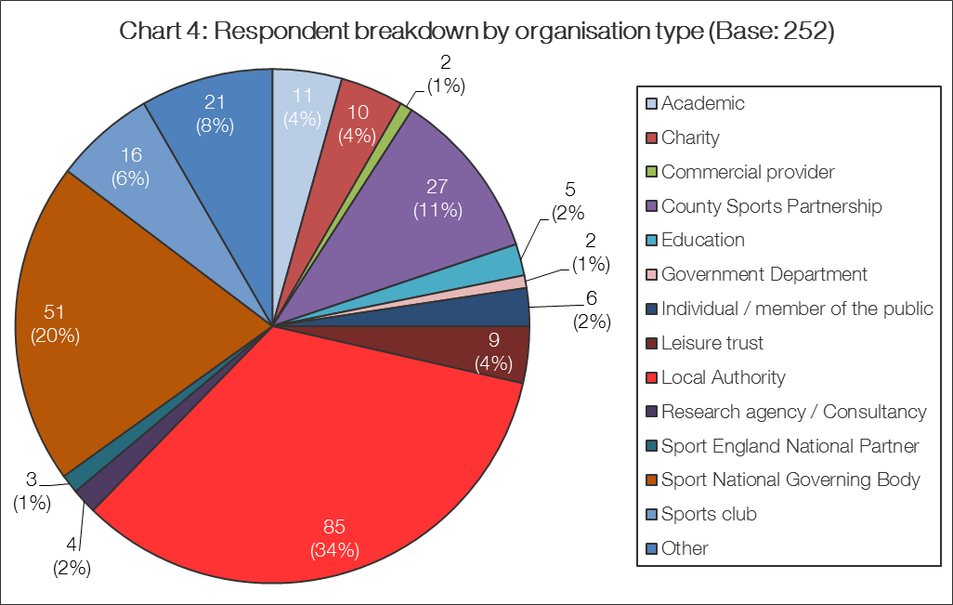

Appendix 2: Local sample boosts
Core cities (sample boost to 2,000):
Birmingham
Bristol
Leeds
Liverpool
Manchester
Newcastle
Nottingham
Sheffield

Other local authority sample boosts
Sample boost to 1,000:
Barking & Dagenham | Plymouth
Barnet | Portsmouth
Bath & North East Somerset | Reading
Bolton | Redbridge
Bradford | Rochdale
Bury | Salford
Cheshire West and Chester | Sandwell
Cornwall | Slough
Coventry | South Gloucestershire
Derby | Southampton
Dudley | Southend
Durham | Stockport
Enfield | Stoke
Greenwich | Sunderland
Haringey | Swindon
Kirklees | Tameside
Lambeth | Thurrock
Leicester | Trafford
Luton | Wakefield
Milton Keynes | Walsall
Northumberland | Warrington
Oldham | Wigan
Peterborough | Wolverhampton
Sample boost to 750:  Cambridge | Oxford
Norwich

