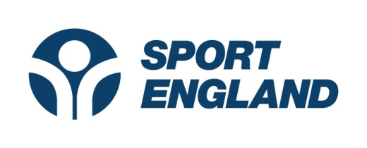
Creating a sporting habit for life
GET HEALTHY, GET ACTIVE – Round 2

Pre-Application Checklist

Please make sure you can answer ‘Yes’ to these statements before developing your application. You may need to refer to the Prospectus or FAQs to answer some of these.
If you are unable to answer ‘Yes’ to any question your application is at risk of being ineligible or something we are unlikely to fund.
- I have checked that my organisation is eligible to receive Lottery funding
- I have read the prospectus and understand the aims of the fund
- My project targets inactive people
- My project meets at least one of the 4 objectives listed in the prospectus
- My project involves the delivery of a recognised sport(s)
- I have looked at the list of what Sport England will not fund and will ensure that my application will not request funding for any of these items
- The amount of funding I am requesting is between £100,000 - £500,000 or I have written permission to apply for funds in excess of £500,000
- My project involves working in partnership with at least one other organisation and I have set out details of our relationship to each other
- I have consulted with local Public Health and/or Clinical Commissioning Group Commissioners.
- I have developed a research / evaluation question for the project and can demonstrate the embedding of the Standard Evaluation Framework for Physical Activity within the planned evaluation approach.
- I am aware of the requirements for partnership funding that my organisation and partners must provide as detailed in the prospectus.
- I have applied under the no partnership funding or less than the minimum expected section of the prospectus and I have attached evidence that partnership funding has been sought but has not been secured.
- I have completed the online application, the delivery plan, budget and attached all relevant supporting documentation as set out in the prospectus.

