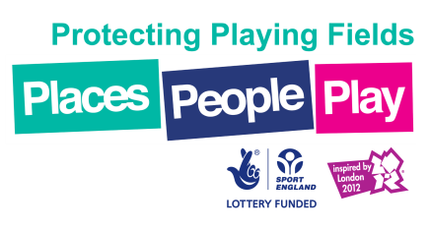

Indicative Project Programme

Post-Award Design, Tender and Contract Administration Schedule

Activity | 2014 |  |  |  |  |  |  |  |  |  |  |  | 2015 |  |  |  |  |  |  |  |  |  |  |  | 2016
 | J | F | M | A | M | J | J | A | S | O | N | D | J | F | M | A | M | J | J | A | S | O | N | D | J | F | M | A | M | J | J | A | S
Applicant notified of Conditional Award
Applicant accepts Conditional Award
Site investigation by Turf Agronomist
Preparation of Feasibility Study Report
Acceptance of Feasibility Study Recommendations
Preparations of Design and Tender documents
Tender Process and Appointment of Preferred Contractor
Pre-Contract meeting with Client, Preferred Contractor and Turf Consultant
Construction Phase (winter games pitches)
Initial 12 Months Maintenance Period (winter games pitches)
Construction Phase (cricket facilities)
Initial 12 Months Maintenance Period (cricket facilities)
Project Completion*

* This Schedule is based on an Award being made in November and should be used as an example only
*The precise date for the return to play for the pitch(es) is highly dependent on the weather conditions that prevail during the construction works and growing-in period. The pitch(es) shall be inspected regularly and play/use shall recommence upon approval from the Turf Consultant

