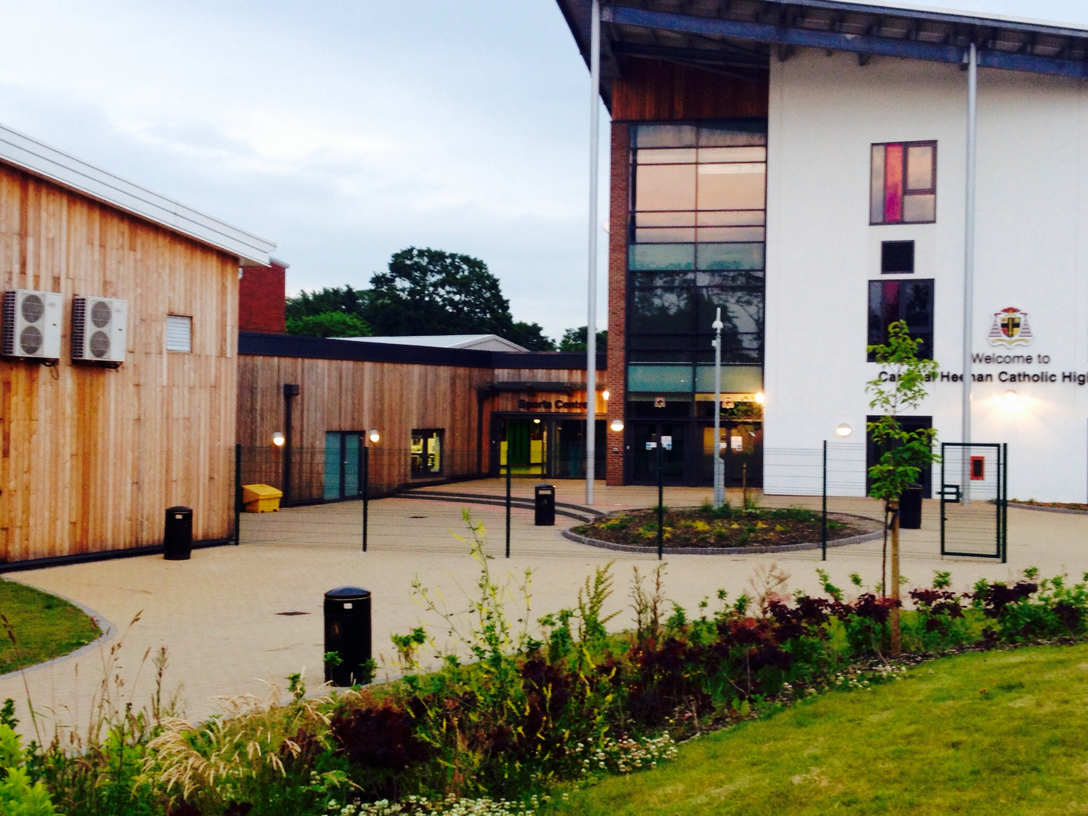
Cardinal Heenan Catholic High School

“Our community can access sport that is cost effective in an environment they trust”

Key Project Data
Type of School: Voluntary Aided (boys school with mixed sixth form)
Size: 1250
Local Authority: Liverpool
Annual no. of Community Users: approximate 76,000 with 1300 account holders (ranging from individual gym members to Clubs)
Location: The school serves an inner city area of mixed wards with some high levels of deprivation and some more affluent pockets.

“We needed to find a way of sustaining our Sports College activity”
Project Background
Cardinal Heenan Catholic High School has a strong identity in the community which has been built up over many years. Over the last 15 years the school has increased their range of sports facilities available to the community with support from a range of capital programmes. The current Sports Hall and Fitness Suite were built as part of a Sports Lottery grant in 1999, and the school engaged the Local Authority Leisure Services to manage these new facilities during community hours. In 2001 the school became a Specialist Sports College, and two years later, a Community Sport Development Manager was appointed to promote the use of the site, specifically targeting sports clubs. A successful bid to the Big Lottery in 2006 enabled Cardinal Heenan to build four new artificial turf pitches to increase their external sporting offer.
In 2012 the school was allocated capital funding as part of Liverpool City Council’s Building Schools for the Future programme. This included demolishing some of the main school and constructing new accommodation on the school tennis courts. Rather than replacing the tennis courts with like for like, the school decided to invest in a full-size 3G pitch.
By 2013, the school were looking for a means of sustaining their Sports College activity, and Leisure Services were also looking to downsize their portfolio due to the economic climate. In a mutually agreeable arrangement, Cardinal Heenan took over the community use management of their sports facilities. This process was driven by the Head Teacher and Community Manager, with support from the Governors. The new management arrangements are still in their infancy, but the school are already seeing financial rewards and soft benefits.

Types of Community Facilities:
Sports Hall –4 Badminton court sized, recently refurbished with ‘Taraflex’ sports flooring.
Large Indoor Multi-use Hall
Dance Studio – accommodates one class
4 x All Weather Pitches (AWPs)– sand based and floodlit
1 x 3G All Weather Pitch – full-size, not floodlit
Grass Pitches
Changing Suites – there are four sets of changing rooms available for community use.

The Fitness Suite is currently still managed by Leisure Services as part of their Lifestyle Fitness portfolio, it has 68 ‘Technogym’ stations of which 50% are Cardio-vascular and 50% resistance based, and a spinning section with 17 Bikes.

There are drinks machines available for the community in the fitness area but there is currently no cafe. The school catering service did pilot a community cafe for one month but it was not consistently profitable, the school may consider trialling this again in the future.

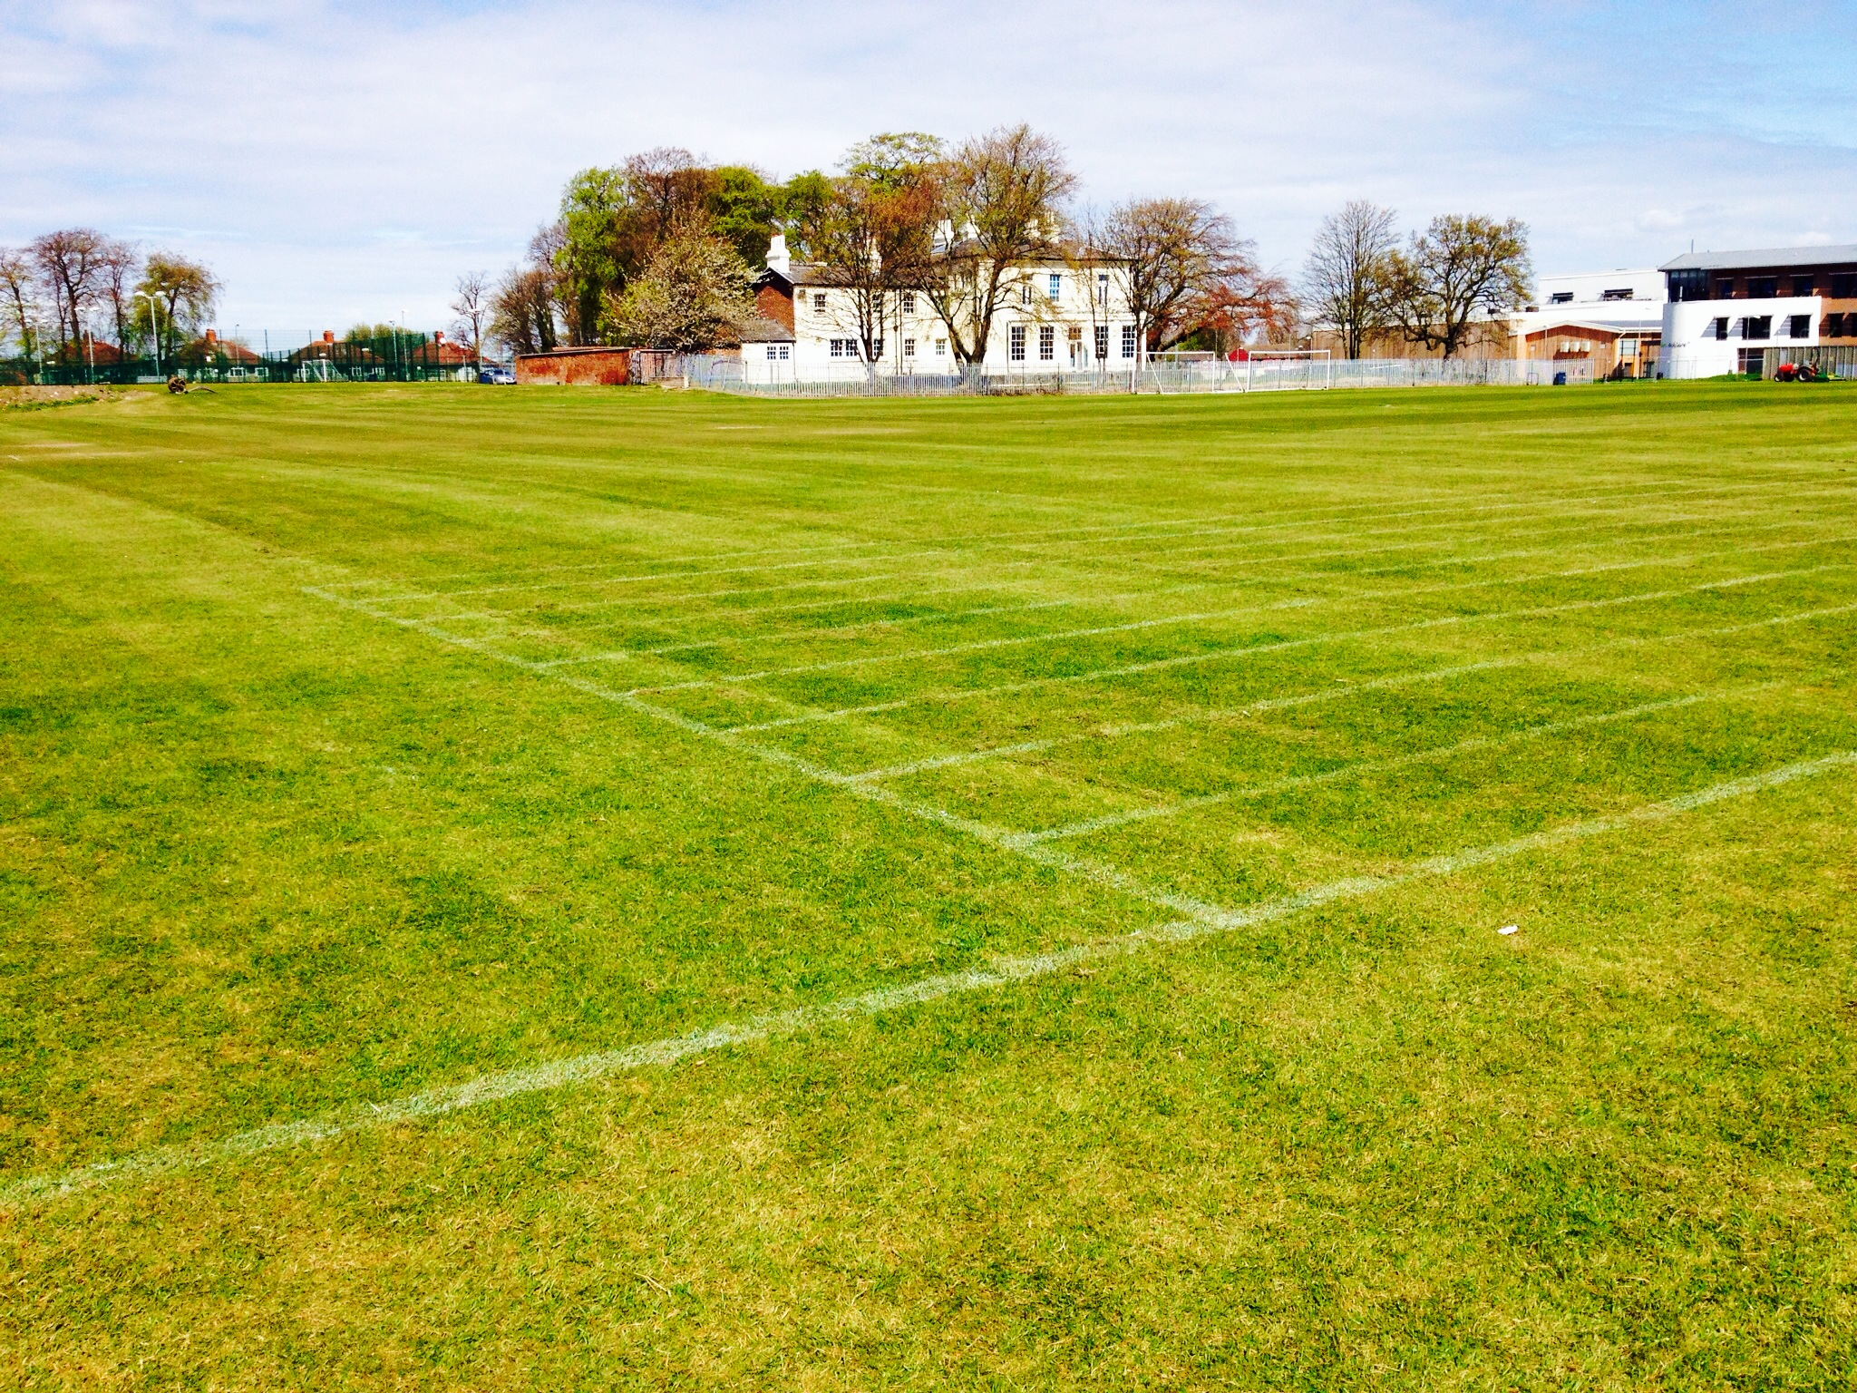
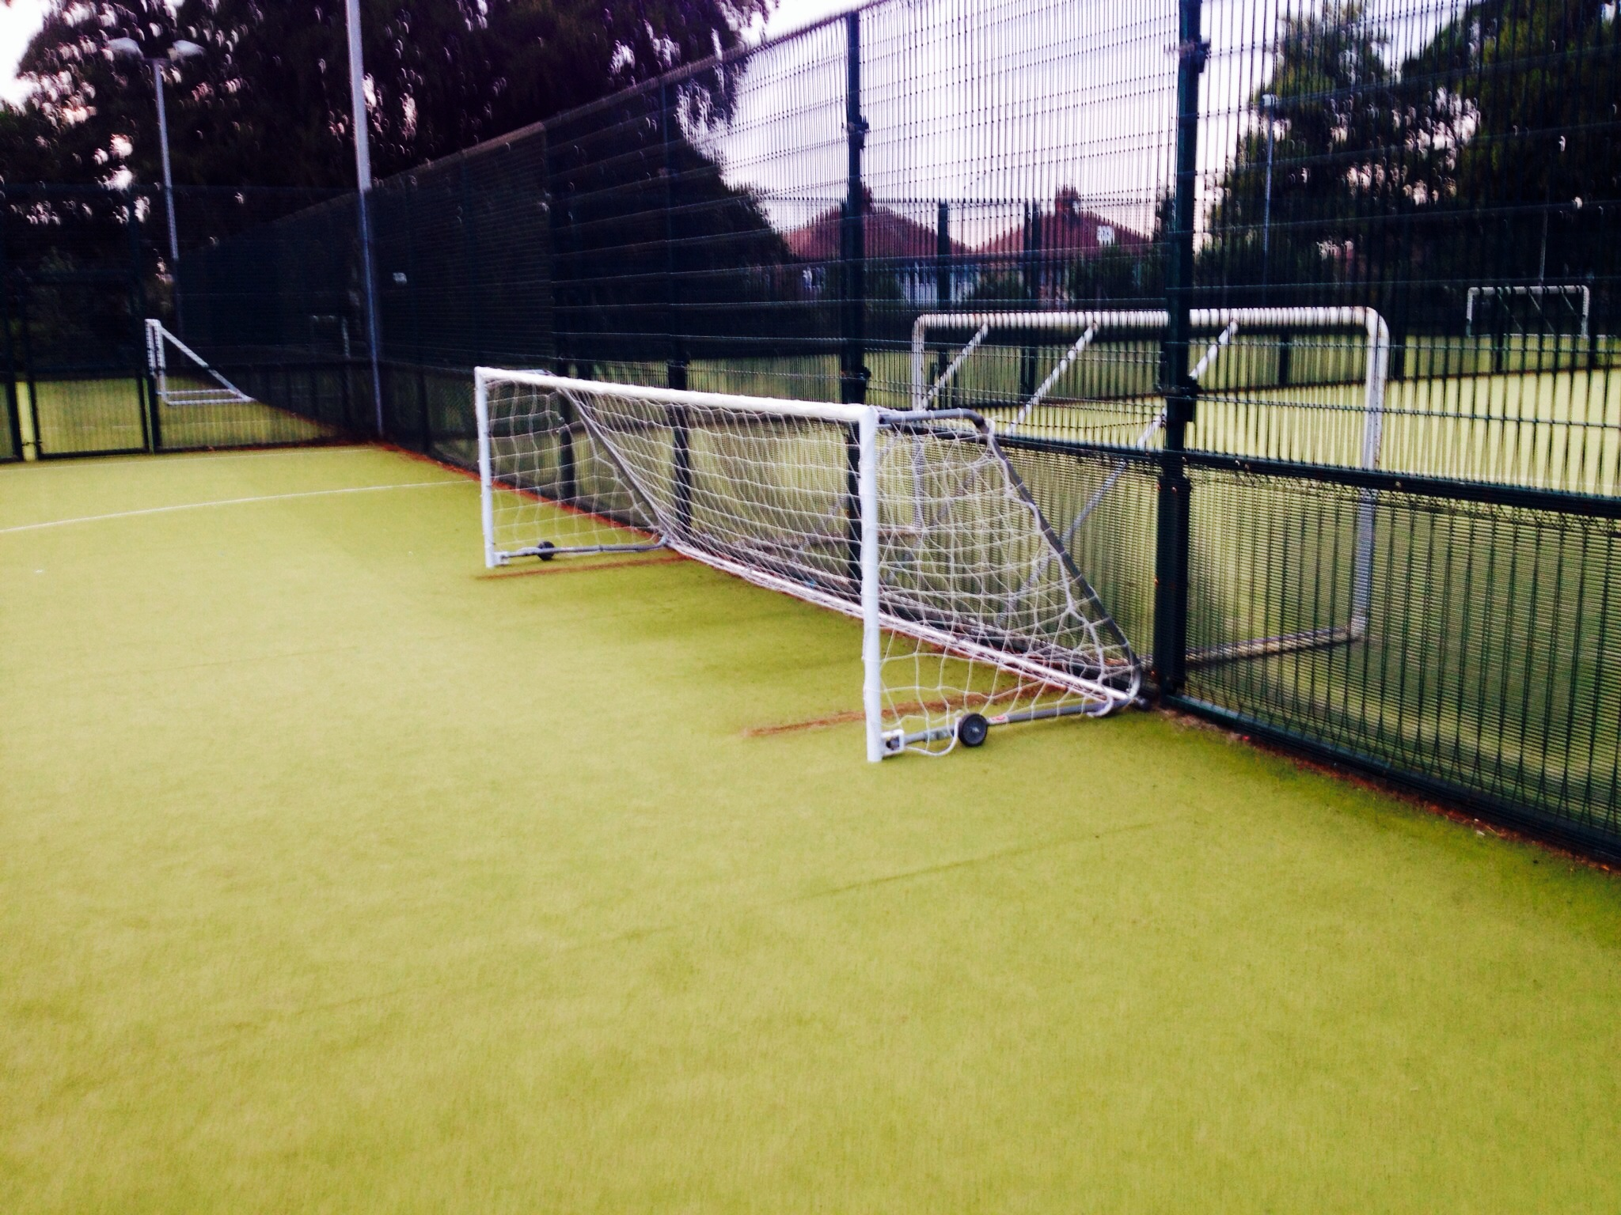
Types of Community Users:
A wide range of sports clubs use the facilities at Cardinal Heenan High School, including Basketball, Running, Cricket, Boxing, Gymnastics, Football, Karate and Taekwondo clubs. The school have developed particularly strong partnerships with two of the clubs which provide them with ‘in kind’ services. For example, Sefton Rugby club use the school pitches for free in summer, and in return the club provide coaching, teacher training and many of the students attend the junior club.
The community booking software allows the school to monitor the usage and profile of participants, the gender split of community use is currently 49% female to 51% male; this is partly due to a very successful Gymnastics Club running over 6 classes on site.
The school have also developed a number of community projects, including a Youth Club which takes place twice a week which is run in partnership with Youth Services and the Police. Young people attending are able to access the AWPs free of charge. Although this programme costs the school money, it is actually viewed as an investment, as when Leisure Services managed community use on site they paid £20k per year for a Security Guard. The school have chosen to avoid paying for additional security and instead offered the youth programme to combat anti-social behaviour, and this solution is working well.

The Community Manager has been proactive in seeking out new and innovative partnerships. For example, the nearby Alder Hey Hospital is being rebuilt with Laing O’Rourke as the main contractor. The school have offered Laing O’Rourke construction workers free use of the AWPs for 5-aside games. In return, Laing O-Rourke are carrying out some much needed upgrades to the AWP fencing free of charge, and are also sponsoring a league with the proceeds going to Alder Hey Hospital.

“The school are now responsible for delivering classes as well as hosting clubs”

Management Model
The community use at Cardinal Heenan is managed directly by the school, apart from the Fitness Suite which is managed and staffed by Liverpool City Council Leisure Services. There is a mixture of ‘pay and play’ and block bookings, and they also accommodate the local authority gym members. The school employs a full-time Community Manager who sits on the Senior Leadership Team and currently reports to the Business Manager. Their role is to oversee the operations, financial management and develop new opportunities including partnerships and funding. In addition, the school employ seven casual community staff with a maximum of three members of staff on duty at any one time. The team consists of two Duty Managers, a Community Receptionist and three Recreation Attendants including Students from the school employed on casual contracts.

Making it work
The school are committed to providing 40 hours of community use per week, as stipulated by their Sport England grant conditions. When community use was managed by Leisure Services, there were some tensions around who was liable for any damage, but now the school run everything they take full responsibility for any incidents.

Financials
The Community Manager is financed from the main school budget. This is a development role, so once the community programme is considered sustainable, it is envisaged that the post will no longer be required. Currently the Community Manager is exploring how to develop adult learning and non-sport community programmes at the school. Income received from community use covers the salaries of the recreation staff, their uniforms and training costs etc. Some of the PE teachers are also paid an additional hourly rate to deliver some of the community sessions, such as Boxercise and Spinning Classes. Over the last six months the school have made between £20 and £30k in profit, with the financial management overseen by the Community Manager and supported by the Finance Manager and Business Manager. Regular meetings between these members of staff ensure the business is kept on track and targets are met. The pricing policy is in line with Liverpool City Council’s leisure provision. As well as a full rate, there is a junior rate which is half price, and a club rate which is a reduced rate for clubs that are delivering benefits to the community and students.
The Fitness Suite is metered separately; the school pay 60% of the utility costs as they use the facility throughout the day, and the local authority pay the remaining 40%. The heating and lighting costs for the school community facilities are subsumed within the main school budget.

Design
The school has been designed so that it can easily be divided into three distinct zones, which can be heated, lit and alarmed separately. Each zone is linked by biometric doors which enables staff to lock down the ‘main’ school and just keep the sport and/or arts zones open during community hours.

Booking Systems
Cardinal Heenan use a software booking system known as ‘Legend’ which is also used across all the Council’s leisure sites. This system generates central records, creates account for users and provides sophisticated financial management to ensure the school meet necessary regulations. The booking forms explain user requirements regarding safeguarding and the rules of third party hiring of the site (see Resource Bank document). The school’s public liability insurance covers the whole site, and a risk assessment for community use is carried out on an annual basis. Any activity that the school is delivering is covered by the school insurance, if a club is delivering an activity then they must be insured.

Ethos
As a Catholic School, and being situated in one of the most deprived cities in Europe, Cardinal Heenan believe they have a responsibility to serve their community and provide cost effective, healthy and positive activities. They are also exploring how they can support the community as part of the Archdiocese of Liverpool ‘s ‘Leaving Safe Harbours’ programme. Working as part of a pastoral area team the school are working collaboratively to increase awareness and impact of the church in the wider community. The school have chosen to retain their Sports College status but as there is now no funding attached to this, so community use is a valuable income generator. All staff are able to use the facilities and take part in classes free of charge, in an aim to improve their wellbeing and consequently the quality of teaching and learning at the school.

Sustainability
The school are already central to sport in the West Derby area, and they now aim to extend this provision to provide adult learning opportunities so that parents can attend classes whilst their children are participating in the sports clubs. The school has a three year plan to increase usage and income, and this includes a marketing strategy and a new gym membership scheme.

Main Challenges
- It was initially a challenge to convince the Business manager and Governing Body that running the facilities in-house was a viable option. The fitness suite remains under the management of Leisure Services as the school were too nervous about taking this over as well.
- Caretaking staff did not adjust well to the changes, in particular their involvement in the later opening times. This consequently had an impact on the quality of their main daily duties. It has now proved more cost effective to employ a Community Team of three staff during community hours rather than employ one school caretaker charging overtime. This arrangement has caused some tensions as the Caretaking staff can perceive the Community Team as a threat.
- The implications of VAT and understanding how the finances work has been a challenge. The VAT charges initially made the school nervous; where possible they try to encourage casual users to make block bookings over more than 10 weeks of the year to avoid VAT charges.

“Staff and students accessing the facilities have improved fitness and positivity levels”
Benefits
- The community programme has raised the profile of the school and increased its positive reputation in the community.
- The income that the school generate from community use is used for refurbishment and new investment. For example, the Fitness Suite has been refurbished with 50% partnership funding from Leisure Services, and the school have invested in new netball posts, basketball nets and backboards for the Sports Hall and football goals for the grass pitches.
- Through managing community use directly, the school have been able to create six new jobs for the local community.
- Students working towards their NVQ Level3 in Fitness Instructing have been delivering personal coaching to members of staff during community hours. This has resulted in eight members of staff losing weight, improving their stress management and consequently having less time off sick.

Top Tips
- The Head Teacher and Governing Body need to be fully on board
- Identify a key member of staff to drive the process (with community management as the majority of their job)
- Set short term achievable goals – don’t take too much on too soon, but build up gradually
- Set realistic income targets – remember some facilities are used seasonally, and don’t assume maximum occupancy levels and maximum hire rates.
- Manage expectations carefully and price facilities appropriately – resist pressure from your community to provide everything for free and have a transparent pricing policy

Contact details
Jake Collin
Head of Community Sport & Sport Complex
Jake.collin@googlemail.com
j.collin@cardinal-heenan.org.uk
07888 760278

