Guidance Note
Instructing Law Firms

Instructing law firms can be a challenging task. This guidance note is designed to help you be effective for your organisation and get good value for money from your lawyers.

This guidance note will help you understand:
- how to assess if you need a lawyer or not to help with an issue;
- what basic information to provide your lawyer with from the outset to ensure bespoke and direct advice can be provided;
- the questions you need to ask your lawyer to ensure you are clear on their process and costs; • what you can expect from your lawyer.

Clarity at the outset will save you money in the future.

This guidance note has been prepared by the Sport and Recreation Alliance, UK Sport, Sport England Sport Wales and Sport Northern Ireland with support and in collaboration with the Legal Panel Framework firms.

We would like to thank the panel firms for their help in pulling this useful guidance note together. More information about the panel firms can be found on the Sport and Recreation Alliance, UK Sport, Sport England, Sport Wales and Sport Northern Ireland websites.

How to assess if you need a lawyer
Before you contact a lawyer it is worth bearing in mind the following 10 Golden Rules:
- Exhaust other sources of advice before you contact a lawyer.
Consider if there are other bodies who can assist such as the Charities Commission; Companies House; Things to Think About (Sport England/ UK Sport); Smart Sport (Sport and Recreation Alliance) or if the issue may have been faced by another NGB who could knowledge share; firms on the panel may have written a newsletter on the issue, check their websites (there are links to the panel firm websites on Sport England, UK Sport, Sport and Recreation Alliance, Sport Wales and the Sport Northern Ireland websites).

- Call a firm on the panel and utilise their free advice helpline.
An informal discussion on the issue may be all that is required. It may be that the issue is a straightforward one and during this conversation the lawyer can put your mind at rest if no action is required or there are simple solutions. The lawyers are trained to identify issues at an early stage in order to save costs and provide early advice or guidance. Please listen to them and, after you have considered their advice, decide whether you wish to follow any actions they ask you to do. If you have any queries or concerns, raise them with the lawyers – do not feel that you have to simply “blindly” follow the advice of the lawyers. Do not be surprised if a lawyer refers you to another lawyer in the firm, it may be that you are asking about a specialist matter and therefore better to get the specialist to speak with you directly.

Please Note: Each of the panel firms has committed to providing a free 20 minute helpline service to sport and recreation organisations. Use of the helpline across the firms will be monitored. We ask you to use the helpline appropriately and respect the generous offering from the panel firms by following the rules below:

  - The 20 minutes free time applies to the first call on new queries/matters only. It does not cover a matter where the firm is already acting for you or dealing with any correspondence in relation to it;
  - This is not a ‘call centre helpline’ and firms may not be able to answer your call immediately. Please do leave a message and the lawyer will return your call as soon as possible;
  - The service covers the call to the designated point of contact for the firm, or on some occasions, when they refer you on to a specialist in that firm to discuss your initial query;
  - If you have contacted another firm on the same query please let the lawyer know. Please note the Collaborators and panel firms will be monitoring use by NGBs and repeated requests to different firms on the same query will be followed up with the organisation;
  - Check if the firm covers the area of law that you require assistance on before contacting them.

- Clarify authorisation levels for individuals to speak to lawyers on behalf of your organisation.
Do not proceed with instructing a firm without internal approval. The firms need to make sure that the instructions you provide are authorised by your organisation so you will need to specifically identify the persons who are authorised to speak with lawyers on any particular issue.

- Set your own expectations for level of advice needed and communicate this clearly to the lawyer.
Discuss and agree as an organisation the level of risk you are prepared to take on this issue and the level of importance that is placed on the advice you receive. You may just be seeking a view for future reference or you may want to have the issue fully investigated so you can maintain your position with confidence.

- Assess and pick a lawyer that is right to help you with the issue.
Ensure you ask the firm to demonstrate if it has the necessary expertise to handle the matter you are discussing with them. If there is time and there is more than one firm on the panel that covers the area of law you need assistance with then speak to more than one firm to weigh up your options. When contacting firms please do tell the firms that you approach that you are speaking with other firms on the panel and be transparent about your process of appointing a firm in terms of how and when you will decide. It is also vital that you choose a lawyer that you feel comfortable with and can understand, so make sure you factor this into your decision and ensure that you speak to the person who will be directly assisting you on the issue.

- Discuss and be clear about the budget you have for the work internally and with the lawyer.
Discuss and agree a budget internally based on an initial scoping conversation with a lawyer. Make the lawyer aware if you have any budget restrictions or concerns the firm should be aware of before proceeding or should know in order to advise on the options for fees. If you need financial assistance then contact the Sport and Recreation Alliance, Sport England, Sport Wales, Sport Northern Ireland or UK Sport for advice on any assistance they might be able to point you towards.

- Collect and prepare all the information you have so you can provide this to your chosen lawyer at the earliest opportunity.
Your lawyer will need all the documents and information you have on the matter to advise you appropriately. This may include documentation or information that is prejudicial to your position or objectives. If in doubt discuss it with the lawyer. This will ensure time is not wasted with documents/information being provided piecemeal and that advice does not need to be amended as key information was omitted. It is worth collating all the information prior to engaging with a lawyer and the template instructing form will help you do this.

- Note down and communicate your timelines.
It is likely you will be working to a timescale where a decision needs to be made by a certain date. It may be a Board meeting in the future or it may be a more immediate date. Ensure you note the dates down so you are aware of them but also so you can communicate these to your chosen lawyer at the outset. The instructing template provides a place for you to note these down.

- Set out your desired outcome.
Be clear about what your desired result is and any specific concerns you have.

- Be clear about the best way for you to receive advice.
All of the firms on the legal panel framework can be flexible with providing you with advice. In some cases you may want regular updates from them and in others you may be comfortable

with updates at significant points during the engagement or at the conclusion. It is also worth considering how you want the advice delivered. In some cases, you may want a discussion as it will be quicker or clearer and in some cases, you may want written information. You may also want both a verbal and a written update. Be clear with your lawyer how you would like them to update and convey information to you.

The basic information to provide your lawyer with
Before you engage a lawyer it is useful for you to collate all of the appropriate information that they might need from you. They will clarify with you what they need, and this can then be passed onto the lawyer to help them understand your issue and your specific needs and in the long run this will assist firms when they act for you on other matters. It forms part of the firm getting to know the client. The more specific the instructions you can give your lawyer at the outset then the clearer and more specific the advice will be. Getting the information to the lawyer at the beginning will save you money in the long-run. It can be difficult knowing what information your lawyer will require from you. If you are not prepared for their questions the process of instructing may take a long time and leave you feeling exhausted and confused.

The form below outlines the typical information that a lawyer will need from you and is the instructing form that all panel law firms will use when you are instructing them.

- You may want to fill this in before you pick a lawyer so you have it ready for the lawyer when you do appoint them;
- You may decide to fill this in once you have appointed a lawyer so you can brief them appropriately in the first meeting; or
- You may decide to discuss the form with your lawyer and fill it in together with them through a discussion.

Regardless of when you use the form, it is a good idea to familiarise yourself with the type of information required on it.

The questions to ask your lawyer

Panel firms went through a thorough interview and procurement process where they were assessed on their ability to communicate clearly with you on their client management and fee arrangements. This should ensure the answers will be provided without the need for you to ask the questions. However, you may wish to review the typical questions below to ensure you have covered everything with your lawyer and there will be no surprises when it comes to cost. The instructing sheet provides space for you to note down the questions you want to ask your lawyer for clarity.

COMMUNICATION COST & FEES

- How the lawyer will ensure - When invoices will be issued?
you know what you are - If travel expenses will be claimed? being charged for? - If travel time will be charged? (If an
- How you will be updated? hourly rate applies);
- How regularly you will be - If ad-hoc phone calls will be updated? charged?
- How your matter will be - If there are other charges that may dealt with by the lawyer with be passed on?
the right expertise?

Guidance notes on filling the form in are provided below. You can download a blank form from the websites of Sport England, UK Sport, Sport Wales, Sport Northern Ireland and the Sport and Recreation Alliance.

Instructing Sheet

If you have contacted one of the panel firms and used their informal discussion helpline to assess that the issue needs instruction then you may need to fill in the form below to help your lawyer understand the issue and begin working with their colleagues on providing you with the advice needed.

Remember to reference the legal panel framework agreement to ensure the discounted rates are offered. Please quote LPF17.

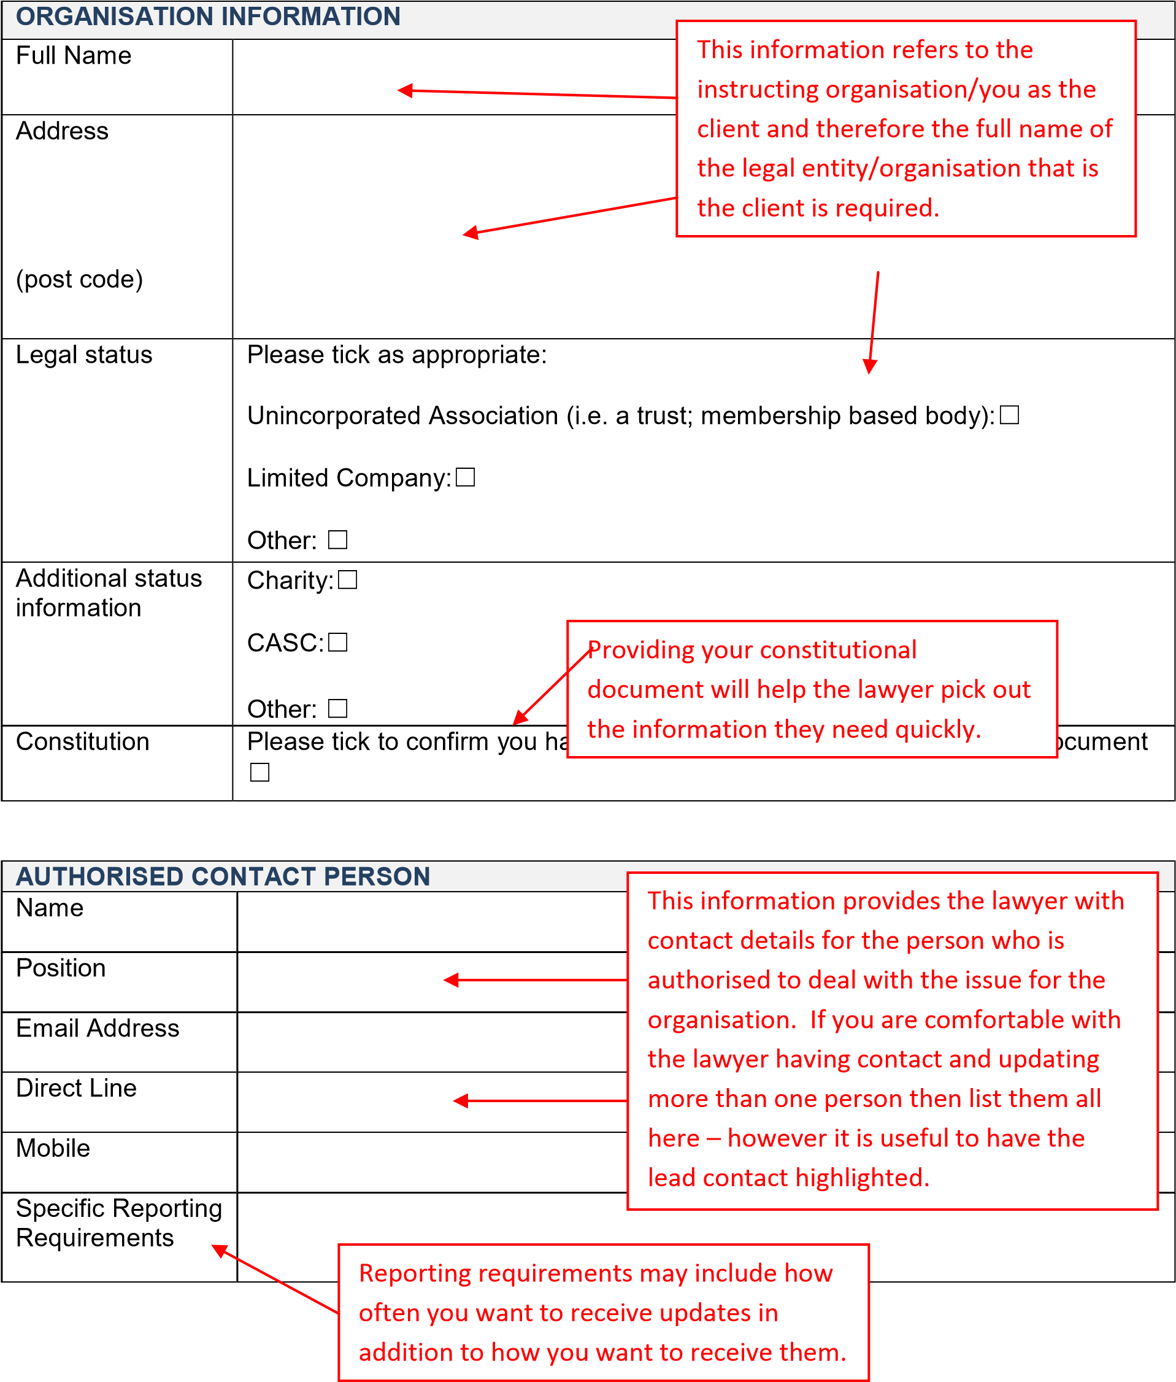

BUDGET AND FEES
Budget Allocation Please tick if you have allocated legal budget to cover this work: and Invoicing ☐
Please list below any information regarding cash-flow and invoicing that the firm needs to be aware of:

In this section give as much information as you can about how and when you will be able
to pay the lawyers. If you cannot pay straight away then the lawyer may be willing to discuss this with you and help with any cash -flow issues.

Third party Please tick if a third party has agreed to pay your legal costs:
payment ☐

Provide address and contact details for them below:

Leave this section blank if you are paying for your own legal costs. If you are involved in a dispute then

check in with your insurers as you may have legal expenses insurance.

Please note that regardless of any agreement that is reached with any third party for the payment of costs, you will remain liable as the client for such costs if the third party does not pay.

Fees Please tick your preferred fee option:

Fixed fee ☐
Hourly rate ☐

Please list below the areas you wish to clarify in relation to fees and costs:

It is worth asking for clarity on the Appointment to the legal panel framework following areas when invoices will be was based on a commitment to provide
issued; services at agreed discounted rates and/or

- If travel expenses will be claimed; fixed/capped fees depending on the issue. If it is something that will be charged for the
- If travel time will be charged (if an hourly firm may need time to look at the instructions
and documentation to provide an estimate or rate applies);
commit to a fixed fee (although this is not
- If ad-hoc phone calls will be charged; possible for all issues). In the experience of
law firms and the collaborators where
- How the lawyer will ensure you know possible most NGBs will go for fixed/capped what you are being charged for; fees on issues as it provides certainty for budgeting purposes.
- Other charges that may be passed on .
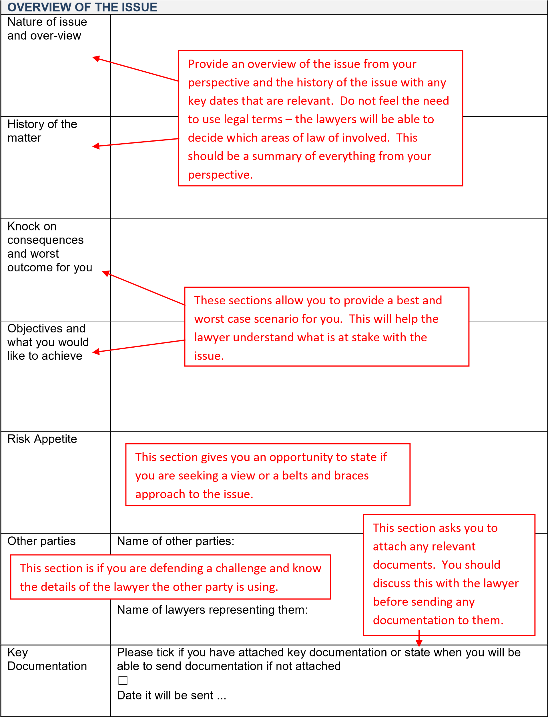
FORMAT AND TIMING OF ADVICE

Format of advice

For some issue
s

such as disputes there will be a need to draft correspondence,
complete forms, and provide advice
–

your lawyer will advise you of this.

Please tick your preferre
d format to receive the advice, if more than one then
tick all that are appropriate:

Face to Face Meeting:
☐

Video Conference
☐

Telephone Conference
☐

Written advice:
☐

Critical Timelines

Please state the date of Board or committee meetings or other

dates where
there are decision making opportunities:

Please state if there is a fixed deadline for when you need advice on this issue
to be finalised:

This section allows you to
highlight your
deadlines and timelines for the work as
well as the way you would like to receive
the advice. This will help the lawyer meet
your expectations.

You may decide to discuss this form with your lawyer before filling it in – however it is a good idea to begin preparing the information in the form for your initial discussion and fill in as much of the form as you can to save time.

What to expect from your lawyer

It can be difficult to know what it is reasonable to expect from a lawyer. Below is a list of five actions you can expect from the panel firms.

1. Compliance checks
Law firms will run compliance checks on the information you provide them with. Included in this they may ask for information on your identity (this is required by the profession and is a legal requirement). During the compliance process the firm will also be checking to confirm if there is any reason why they may not be able to assist you on the specific issue. This could be due to:
- a lack of expertise in the specific area;
- a conflict with a current client or the firm is about to engage with a new client with whom you are or may enter into negotiations with or be in dispute with. This is normal. Firms are required to undertake conflicts of interest checks when acting for clients. A definition of conflicts of interest can be found in the glossary. If a conflict is present then the firm will tell you and you can then seek advice from another firm on the panel who can assist.

2. Regular updates
The firm will maintain a regular dialogue with you and keep you informed of any substantial updates throughout the issue. This should allow the lawyer to check if there has been any change in the scope or circumstances. The lawyer will discuss with you how they will update you and how often this may happen.

3. Managed transitions and handovers
During the time of advice it may be appropriate for the issue to be passed to a different lawyer. This may be because a different area of law is involved and expertise is needed in a different area or it may be because an individual lawyer is absent and their work is being covered. During the time of advice your lawyer should ensure you are updated on any changes in terms of the provision of advice and you have direct contact with the lawyers advising you.

4. Efficiencies and knowledge sharing
In some situations the lawyer may have provided similar advice before to another NGB. If this is the case then they should be able to help you on a reduced fee because the workload will not be so great for them. They may also be able to run training sessions or workshops on the issue to help a number of NGBs with an area of law. The lawyer should be looking to drive efficiencies for the sector and share knowledge across organisations.

5. Clarity of advice
Your lawyer should put themselves in your shoes and provide clarity and direction on the issue you need help with.

Glossary

Capped Fees
The maximum fee that the client will be charged for the agreed scope of work. If the scope of work costs more to deliver than estimated the risk is with the firm. If the work costs less than the estimated cap then the lesser amount would be charged.

Client
In most cases this will be the NGB or the organisation that is seeking advice.

Counsel
Counsel is used to refer to a barrister who is instructed by the law firm on a particular case.

Client Relationship Partner/Manager (CRM or CRP)
Designated point of contact for the firm under the panel agreement.

Client Care Letter
Letter from the firm setting out the nature of your instruction; the name of the lawyer(s) who will be dealing with your issue; their contact details; likely timescales; costs estimate on panel rates or fixed fees; who you have to report any complaints to and the process of dealing with complaints about the services you have received.

Client Care Partner
Partner of a firm who usually handles and oversees the complaints process.

Conflict of Interest
Law firms are required to check for conflicts of interests between them and you as a potential client or client; and if there is a conflict between you as a client or potential client and its current client base (e.g. they may be already acting for person or organisation that you are dealing with). If this occurs they must explain this to you and may refer you to another firm on the panel.

Please note: panel firms retain the right to work for individuals and organisations not represented or supported by Sport England, UK Sport and the Sport and Recreation Alliance. This may result in them sitting on the other side of the table from you for specific matters.

Disbursements
Money and expenditure paid out on behalf of the client. Disbursements will be passed onto the client to reimburse the firm for their expenditure. (E.G. third party fees incurred by the firm on your behalf such as companies house and/or land registry search fees; court fees; expert fees; barrister's fees).

Engagement Letter
The same as a client care letter.

Fixed Fee
Is the maximum fee that the client will be charged for the agreed scope of work irrespective of whether the work takes less or more time to deliver.

Hourly Rates
The hourly rate charged by the firm for the lawyer’s time spent on the instructions. The rate will depend on the lawyers experience and position within the firm. Some firms offer a blended hourly rate which is one set rate for all lawyers irrespective of their experience. The hourly rates quoted will be exclusive of VAT.

Money Laundering
Concealing the source of obtained funds which law firms are required by law to carry out checks against.

