Swindon Community Tennis, St Mark Recreation Ground, Swindon
What this case study is about?
This is the story of how public tennis facilities were improved, kept open, accessible and affordable for local people to enjoy. The key theme of this project was the creation of a community trust made up of local partners to oversee and operate the venue for the benefit of local people. As is many situations the local authority has faced reductions in funding so that they could no longer operate facilities and were looking for solutions to keep facilities available for public use.

The site, situated in St Mark’s Recreation Ground in Swindon, has been significantly improved with almost £700k of investment into the courts, pavilion and car parking areas. A new business model has been put in place which maintains wide public access whilst bringing some dedicated income to help maintain the courts. The Lawn Tennis Association has been heavily involved and this forms part of their strategy to create strong partnerships with Local Authorities and to create flagships for public participation in tennis.

Figure 1: The Tennis Courts at St Marks Recreation Ground Swindon:

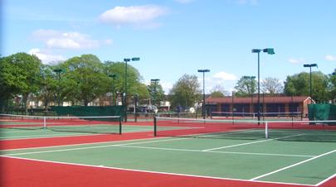

What was the challenge?

Like many Local Authorities around the country Swindon Borough Council faces a declining budget for maintaining parks, open spaces and public sports facilities. There was an inconsistent mechanism for generating income from use of the tennis courts. It wasn’t sufficient to cover the costs of maintenance and as such the courts were in a declining state. The courts were open to the public and were also the base for a local tennis club who paid an annual fee to the Council. The Club administered public payments when its committee members were on site, but this was inconsistently ‘manned’ with the courts being free and open the majority of the time.

The Council was therefore considering an options appraisal exercise with the incumbent club on site to take over and operate the tennis courts. The feedback from local councillors and the local community was that they were very keen to ensure the courts remained accessible, affordable and community led for 3 key reasons:

- The long term sustainability of the site i.e. income generated is reinvested.
- It formed part of the community and performed a community function outside of tennis alone
- Swindon has few public tennis courts and this is the largest collection.

The Council were able to invest a significant sum from developer’s contributions into the site to build a new community building, but needed to consider the correct operating model for the courts and indeed the community building.

Swindon Community Tennis Club (volunteer run) were keen to take over the courts but needed to find a number of partners to work with to facilitate how this venue would operate day to day. So a new operating model solution was needed.

Figure 2: Community Building at St Marks Recreation Ground, Swindon

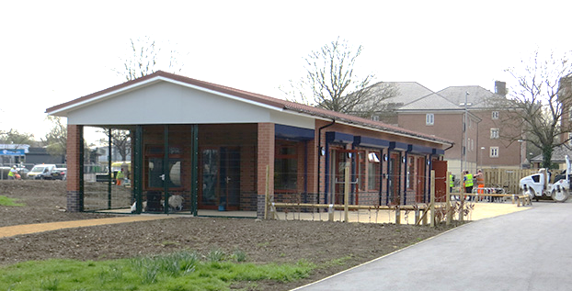

What was the solution?
The LTA Regional Participation Team supported this process by using existing knowledge and insight to create a new community owned operating model. A key part of this model was considering each of the different functions that the site has:

- Community Court Access
- Club Usage
- Coaching Provision
- Community Building

For the court access ‘key fob’ access technology was used to allow court access as times when the site was not manned. This model is designed to provide low cost access to players that sign up, generating income to reinvest in the courts maintenance. Simply a household could pay £30 for a key that would grant year’s access to the courts. The Club continued to operate as normal on the same site with organised league matches and club nights.

Central to this management is the online booking system which is the Lawn Tennis Association system ‘Clubspark’. It is a simple, easy to use system to book courts. Players simply set up a log-in to access the booking system and books courts for them to play. They can log in with an LTA member login, Facebook, Google or Microsoft login. If they don’t have any of these they can just set up one using Clubspark.

The exclusive rights to provide the coaching for these courts was tendered to the market and an interview process was conducted. The incumbent coaching provider is Community Tennis Association who have a coaching team running a growing programme on site.

The community building now houses a café that is open at weekdays and weekends and the associated space is hired out to community groups for things like dementia groups, toddler groups and luncheon clubs.

The LTA worked with SBC, Swindon Tennis Club, local councillors and other local stakeholders to come up with a governance plan and business model for ‘Swindon Community Tennis’. This newly created Charitable Incorporated Organisation (CIO) was established with the sole purpose of running a community based tennis facility and promoting community participation in tennis.

The plan was approved by SBC Members as work was going on to refurbish the courts, build the community pavilion and make improvements to the surrounding park and parking area. The Council provided £600k and the LTA put in £80,000 towards resurfacing the courts. The capital works were all managed by SBC.

The new CIO was registered with the Charity Commission with three founding Trustees and with non-exec partners such as Swindon Borough Council, the LTA and the County Sports Partnership joining meetings where relevant. The charity was offered a full repairing peppercorn 25 year lease on the St Mark’s tennis courts and clubhouse.

The courts were relaunched on the 17th May 2015 under the new management model which is represented in the figure below.

Figure 3: Organisational Structure – Swindon Community Tennis

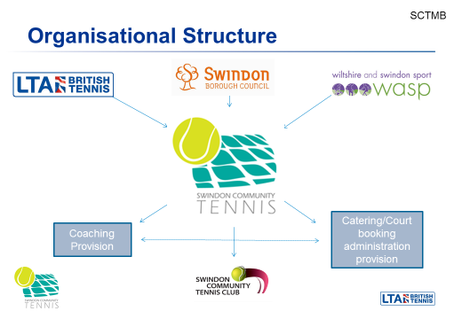

What is the Business model?

The Business Case projects an annual spending budget of about £30,000, with £15,600 going into a ring-fenced maintenance fund to cover future resurfacing, floodlight replacement and fencing repairs. There are minimal staff related costs so the main costs over and above site maintenance, are utilities and marketing activities. The maintenance fund is to be transferred into a ring-fenced account held by the Swindon Community Tennis, so that they can manage any future capital works, thus avoiding the payment of VAT.

The main income streams are the sale of key fobs at £30 per household, followed by the rental contribution from the tennis club, the coaching team and the café operator at the site. There is has been initial revenue grant from the LTA but longer term this project will not require any subsidy.

It is anticipated that a significant profit above the maintenance requirements is possible but this relies on steady income streams. This in particular looks at the sales of public court access key fobs which in year 1 was 300+ and rising to 500 in the current year 2. These are deliberately ambitious targets based on high sales and court usage we have seen in other case studies that informed this project.

The other income stream is the operation of a cafe in the pavilion building which provides another rental income and is operated by a family run business.

What was the result?

The project is still in relevant infancy but the signs are that it is working very well. A few of the key statistics are listed below.

- A £700k investment into public tennis courts and community building in the heart of a community.
- Transfer of the courts to a community led model that the council no longer need to subsidise.
- Over 300 households and over 900 unique people playing tennis on the courts in Year 1
- Increase of club memberships from 45 – 60
- Over 300 unique people attending free open days in the first year.
- A replicable sustainable business model for public tennis courts
- Over 60 people signed up to the coaching programme
- Multitude of community groups using the building and café for their activities.

Figure 4: Website and Facebook Page – Swindon Community Tennis

Top Tips

- Create a strong partnership with the Local Authority and the relevant Sport Governing Body

- Create new management vehicles if there are no existing groups willing or able to take over management

- Ensure you build in a sinking fund into the financial plans.

- Find a business model which balances affordability and access with income generation.

- Make the best use of technology for bookings and access etc.

Case study contact details (to be published on Sport England website) | http://swindoncommunitytennis.org.uk/play-tennis/
Photographer(s) name(s)
Photo 07 (small - preferably landscape) + caption
Submission to include separate Tiff / Jpeg file for image (approx 0.5-1.0Mb)

Photo 06 (small - preferably landscape) + caption
Submission to include separate Tiff / Jpeg file for image (approx 0.5-1.0Mb)

